
Fast National University of Computer & Emerging Sciences

Human Computer Interaction
Deliverable-2

Synthesis Report, Problem Statement and Requirements

Instructor:

Dr. Javeria Imtiaz

Section: BSCS-7B
Member 1: Muneeba Zaheer (23i-0581) Member 2: Armish Tauqir (23i-0786) Member 3: Areej Fahim (23i-0504) Member 4: Warisha Shaukat (23i-0809)

Table of Contents
1. Introduction and evidence base: 2
Core task used throughout D2: 2
Did the D1B evidence support the D0 assumption? 2
Evidence base carried forward from D1B: 2
Coding, traceability and privacy conventions 2
Part 1. Synthesis 4
1.1 Affinity diagram: process evidence (Stages 1 to 5) 4
Stage 1. Raw notes: all evidence laid out before any grouping 4
Stage 2. First grouping: notes moved into piles by similarity 8
What we noticed at the end of Stage 2 12
Disagreements and outliers discussed during regrouping 15
Stage 4. Naming: clusters named after the pattern became visible 15
Final affinity diagram 18
Stage 5. Ladder: from themes to insights to needs 20
1.2 Themes, insights and needs (summary of the strongest clusters) 23
1.3 Evidence-grounded personas 24
Persona A: The Careful First-Timer (grounded in H and I) 24
Persona B: The Lookup User (grounded in F and G) 25
Persona C: The Try-First Fixer (grounded in J) 26
1.4 Journey map of the core task 27
2. Part 2. Problem framing 28
2.1 Hierarchical task analysis (two levels) of the core task 28
HTA in tabular form, with observed breakdowns from D1B 28
What the HTA shows 29
2.2 Point-of-view (POV) statements 29
POV-1: Persona A and the matching problem (T1) 29
POV-2: Persona B and the outside-help problem (T3) 30
POV-3: The machine-response problem (T2) 30
2.3 How-Might-We (HMW) questions 30
Calibration: HMW drafts that were rejected 31
Example of one HMW being refined 31
3. Part 3. Requirements 32
3.1 User stories 32
3.2 Measurable requirements 32
R1. Correct identification of parts and symbols 33
R2. Reaching the right instruction 33
R3. Safe order, no cautioned actions 34
R4. Understanding responses, confidence 34
R5. Perceivable and understandable 34
3.3 Category spread and theme coverage 35
3.4 Traceability matrix 35
4. Part 4. Limitations and hand-over to D3 36
How D3 will use this document 37

Introduction and evidence base:

Core task used throughout D2:
setting up and starting an unfamiliar household appliance for its first task, using its printed manual. In D1B this was observed as "set up and start a wash for a heavy load" on a Panasonic NA-F135A1 top-load washing machine (Participants F, H and G) and "take the inner basket out, then set up and cook thin frozen fries" on a mechanical-dial air fryer (Participants I and J)

Did the D1B evidence support the D0 assumption?
Partly. Our D1B evidence confirms the core of D0: participants could not reliably map what the manual showed to the physical machine (theme T1, seen in all three washing-machine sessions and both air-fryer sessions). Synthesis also surfaced problems that D0 did not predict and that change the framing: the machine's own normal responses (display number, lid lock, drawer pause) were read as faults (T2); quantities and settings were present in the manual but could not be acted on (T4); and for four of five participants the manual is not the first place they look at all (T3). D2 therefore frames the problem around certainty at the moment of action, not around the manual's diagrams alone.

Evidence base carried forward from D1B:
Five contextual-inquiry sessions were run in D1B. Every unit of evidence in this report comes from those sessions only; nothing was added from outside the fieldwork.
ID | Appliance | Profile | Task outcome | Manual use | Outside help
F | Washing machine | 18-24, student; family uses a twin-tub; never ran an automatic machine | Completed in 7 min; overfilled drum; guessed tray symbol | Contents twice; about 4 consults | YouTube (about 1 min) before pressing Start
H | Washing machine | 25-34, student; never operated any washer; reads manuals from page one | Completed in 7 min with one self-correction (wrong compartment) | Linear from first English page, then contents | WhatsApp photo and voice note to sister (no reply)
G | Washing machine | 25-34, postgraduate; runs own household; owns a front-loader | Completed in 5 min; unsure about water level | Two consults (program table, detergent) | None during task; Google/YouTube is her first resort
I | Air fryer | 18-24, student; household owns the unit; never operated it; reads from page one | Completed in 7 min; unsure about preheat and guard | Page order throughout | None
J | Air fryer | 18-24, student; household owns the unit; never operated it; tries the machine first | Partly: preheat skipped, basket overfilled, near-drop of basket | Once, only after the near-drop; landed in French section | YouTube before opening the manual

Coding, traceability and privacy conventions
Item | Detail
Evidence unit (sticky note) | One observation, quote or behaviour from one participant at one moment. Never two facts on one note.
Note ID | Participant letter + sequence number, e.g. F-07 is the seventh evidence unit from Participant F.
Note type | O = observation recorded by the interviewer; Q = participant quote (Roman Urdu kept as spoken, English gloss in brackets, as in D1B); B = behaviour (what the participant did).
Source reference | D1B section plus timestamp or question, e.g. "4.3.4, 00:07:42" (Participant F hesitation log) or "5.4.6, Q7" (Participant J post-task answers).
Tool | We executed the synthesis process manually on a physical wall using paper sticky notes with explicit evidence codes (e.g., F-01, H-12) to group, cluster, and ladder all 59 notes drawn from Document D1B without using digital or generative AI tools. We conducted the synthesis across five distinct physical phases—Raw Notes Placement, First Grouping, Regrouping & Refinement, Cluster Naming, and Laddering (Themes → Insights → Needs)—all of which we captured in high-resolution photographs embedded in Section 2.1 and documented via a continuous video submitted separately through the course portal.
Privacy | Participant letters only. No names, faces or identifying details.

Part 1. Synthesis
Part 1 turns the 59 evidence units into themes, insights and needs (1.1 and 1.2), then into evidence-grounded personas (1.3) and a journey map of the core task (1.4). Section 1.1 is the process document required by the D2 brief: it records how the affinity diagram evolved, stage by stage, with the reasoning at each step.

1.1 Affinity diagram: process evidence (Stages 1 to 5)
The brief requires that we build the affinity diagram bottom-up from D1 evidence and that we show how it evolved, not only the finished board. This section therefore records five stages in order: raw notes, first grouping, regrouping, naming, and the ladder from themes to insights to needs. Each sticky note is drawn as a rectangle shape coloured by participant; the board at each stage is shown, and the reasoning that moved notes between stages is written beside it.

Stage 1. Raw notes: all evidence laid out before any grouping
Here are the raw notes:
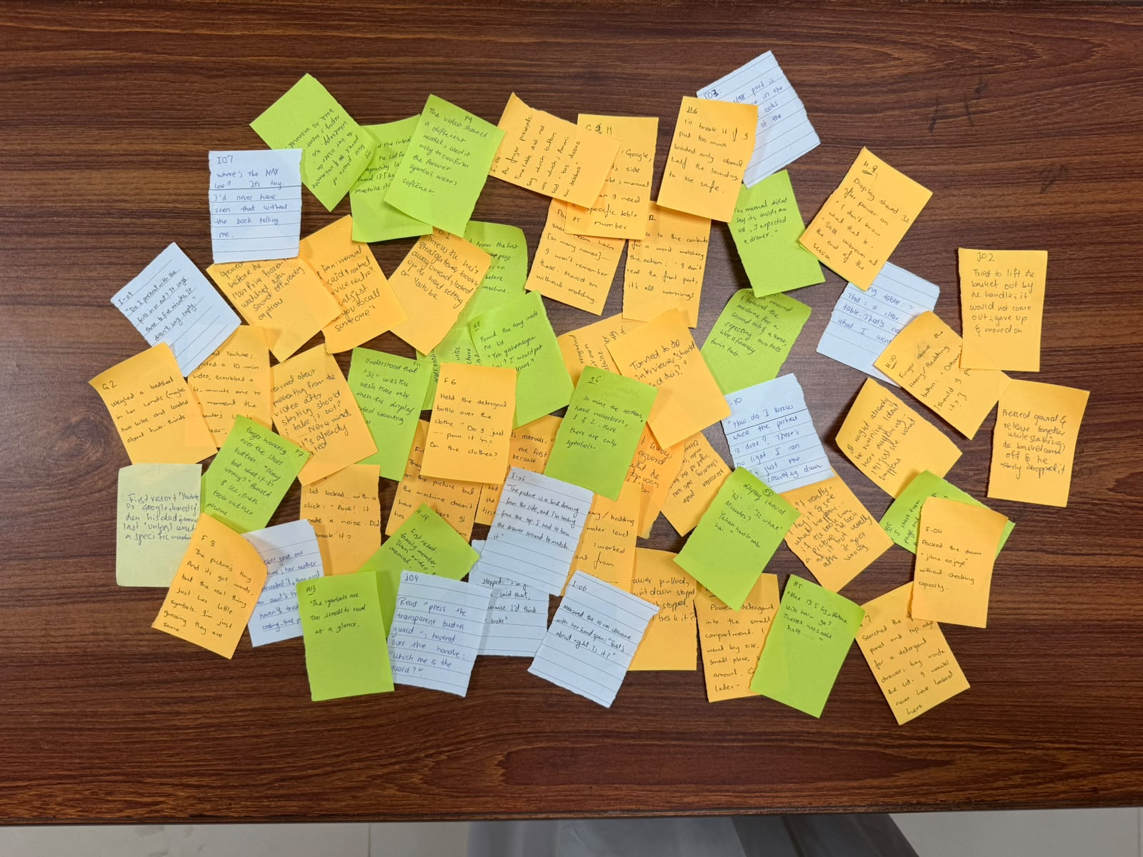
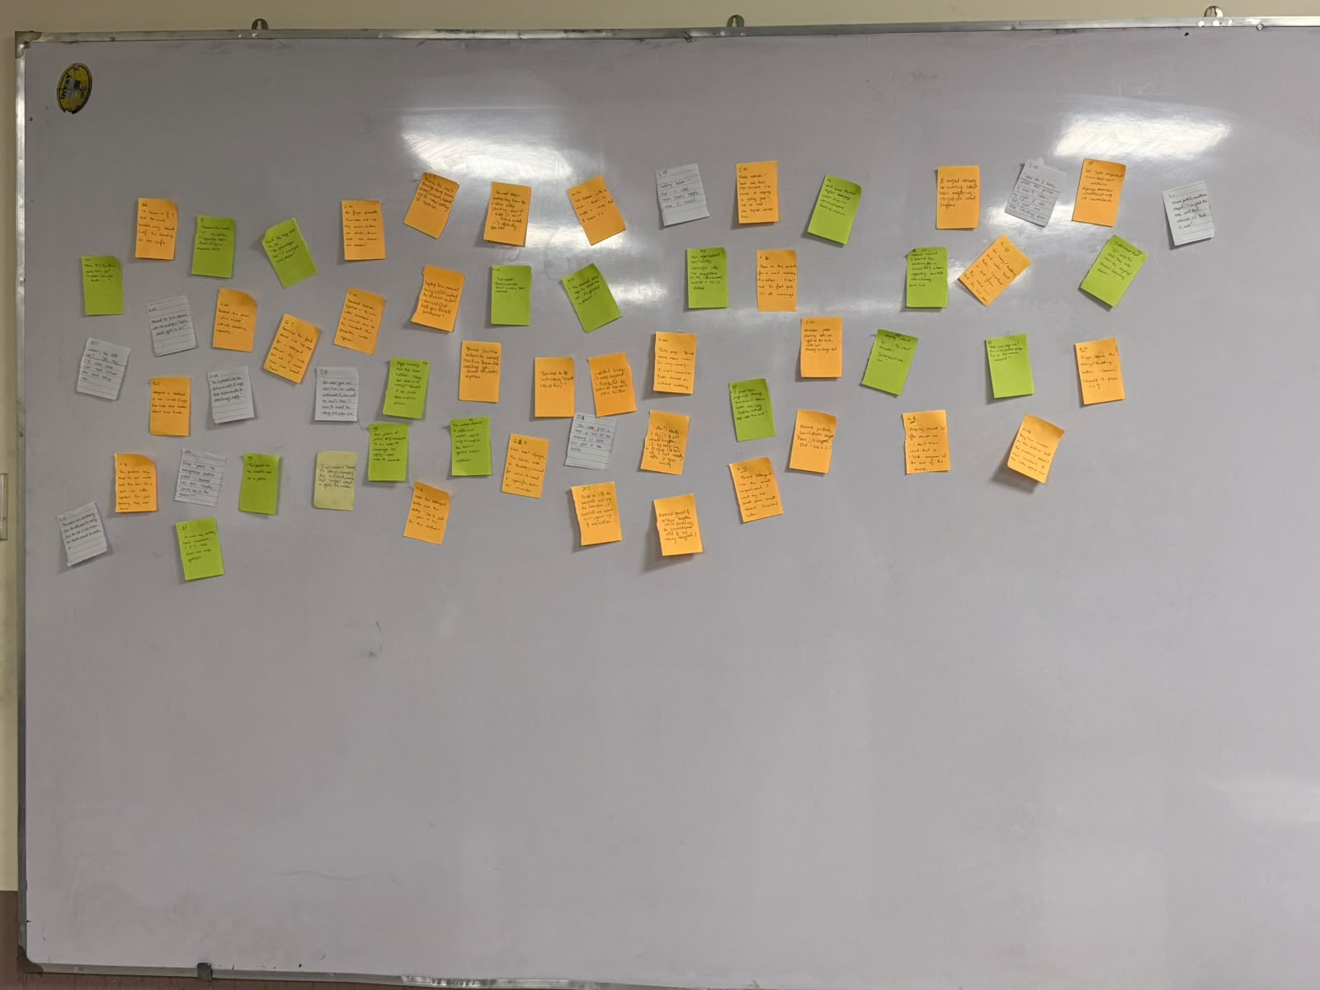
Two of us went through D1B Parts 4 and 5 line by line... A third team member checked that every hesitation-log row and every post-task answer had at least one note, and that no note combined two findings. Interviewer probes and protocol notes were not turned into notes, because they describe our method rather than the users.
The notes below are laid out in session order exactly as written, before anyone grouped anything. No note was edited, merged or discarded at this stage.
Participant | Appliance | Observations | Quotes | Behaviours | Total notes
Participant F | Washing machine | 2 | 6 | 5 | 13
Participant H | Washing machine | 0 | 11 | 3 | 14
Participant G | Washing machine | 1 | 4 | 3 | 8
Participant I | Air fryer | 0 | 10 | 2 | 12
Participant J | Air fryer | 1 | 7 | 4 | 12
All | 2 appliances | 4 | 38 | 17 | 59

Participant F (Washing machine; 18-24, student; family uses a twin-tub; never ran an automatic machine): 13 notes
Note ID | Type | Note as written on the wall | D1B source
F-01 | B | Looked around and behind the machine for a second tub and a hose, expecting two tubs like the family twin-tub. | D1B 4.3, 00:03:37
F-02 | Q | "They have numbers on the picture but the machine doesn't have numbers. It has little picture icons." | D1B 4.3, 00:04:12
F-03 | Q | Display showed "32": "32 what? Minutes? Yahan knob nahi hai [there's no knob here]." | D1B 4.3, 00:04:54
F-04 | B | Packed the drum "jitna aa jaye" [as much as fits] without checking capacity. | D1B 4.3, 00:05:36
F-06 | B | Held the detergent bottle over the clothes: "Do I just... pour it in? On the clothes?" | D1B 4.3, 00:06:32
F-07 | B | Finger hovering over the Start button: "Okay, but what if it's wrong?" Paused 8 seconds, then took out her phone. | D1B 4.3, 00:08:17
F-08 | Q | "The picture's tiny. And it's got words, but the real thing just has little symbols. I'm just guessing they are the same." | D1B 4.3, 00:07:42 (probe)
F-09 | O | The video showed a different model; used it only to confirm that the flower symbol means softener. | D1B 4.3, 00:09:34
F-10 | B | Searched YouTube; rejected a 10-minute video, scrubbed a 4-minute one to the moment the presenter's hands appear. | D1B 4.3, 00:08:31
F-11 | O | Understood that "32" was the wash time only when the display started counting down. | D1B 4.3, 00:09:55; Q4
F-12 | Q | Goes to the contents for a word matching the action: "I don't read the front part, it's all warnings." | D1B 4.3, Q3
F-13 | Q | Hair dryer booklet was "mostly warnings" with one tiny picture of the attachment; twisted it till it clicked. | D1B 4.3, Q1
F-14 | Q | Air fryer presets: the time table did not say which button was which; Ammi said "bas dabao aur dekho" [just press and see]. | D1B 4.3, Q6

Participant H (Washing machine; 25-34, student; never operated any washer): 14 notes
Note ID | Type | Note as written on the wall | D1B source
H-03 | B | Read from the first English page, about 60 seconds on warnings, before touching the machine. | D1B 4.4, 00:03:37
H-04 | Q | Parts page: "Bohat saare naam hain [so many names]... I won't remember these." Moved on without matching. | D1B 4.4, 00:04:54
H-05 | Q | "Max 13.5 kg. Kitne kilo hain ye? [How many kilos is this?] There's no scale here..." | D1B 4.4, 00:05:29
H-06 | Q | "I'll break it if I put too much." Loaded only about half the laundry to be safe. | D1B 4.4, 00:05:29 (probe)
H-08 | Q | Display showed 32 after power on: "I don't know what that is." Still unknown at the end of the session. | D1B 4.4, 00:07:00; Q4
H-09 | B | Sent a photo of the panel and a voice note to her sister on WhatsApp; no reply; went back to the manual. | D1B 4.4, 00:07:21
H-10 | Q | Finger above the Heavy/Bedding button: "Dabaun? [Should I press it?]" | D1B 4.4, 00:08:24
H-11 | Q | Found the tray inside the lid: "Yeh yahan kyun hai? [Why is it here?] I would put it in the drum." | D1B 4.4, 00:08:45
H-12 | B | Poured detergent into the small compartment: "I went by size, small place, small amount." Corrected later. | D1B 4.4, 00:08:45; 00:09:20
H-13 | Q | "The symbols are too small to read at a glance." | D1B 4.4, 00:09:20 (probe)
H-14 | Q | Lid locked with a click: "Arre! It made a noise. Did I break it?" | D1B 4.4, 00:09:55
H-15 | Q | "I start from page one. Always. But then it takes forever, and I only find the actual steps near the end." | D1B 4.4, Q3
H-17 | Q | "The manual didn't say it's inside the lid, I expected a drawer." | D1B 4.4, Q5
H-19 | Q | First resort: a family member, then a video, then the manual. | D1B 4.4, Q7

Participant G (Washing machine; 25-34, postgraduate; runs own household, owns a front-loader): 8 notes
Note ID | Type | Note as written on the wall | D1B source
G-01 | B | Checked the inside of the lid for a capacity label; found 13.5 kg on the machine itself. | D1B 4.5, 00:03:36
G-02 | B | Weighed a bedsheet in her hands ("maybe two kilos") and loaded about two-thirds. | D1B 4.5, 00:04:08
G-03 | Q | "Yeh icon kya hai? [What is this icon?] This is a water drop... this is the timer, shayad [maybe]." | D1B 4.5, 00:04:26
G-06 | Q | "In mine the sections have numbers, 1 and 2. Here there are only symbols." | D1B 4.5, 00:07:24
G-07 | B | Searched the front panel and top edge for a detergent drawer; the tray was inside the lid: "I would never have looked here." | D1B 4.5, 00:06:56
G-08 | O | Lid lock recognised from her own machine; display number understood only at the countdown. | D1B 4.5, 00:07:59
G-10 | Q | "On Heavy/Bedding and water level Auto, I worked it out from the table... but I'm not sure." | D1B 4.5, Q4
G-11 | Q | First resort: Google, the brand's site or YouTube; the manual is "for when I need a specific table or number". | D1B 4.5, Q7

Participant I (Air fryer; 18-24; household owns the unit, never operated it): 12 notes
Note ID | Type | Note as written on the wall | D1B source
I-01 | Q | Reads manuals "from the first page, because I'm scared of skipping a safety part"; had to find the English section first. | D1B 5.3, Q1
I-02 | Q | Microwave plate cleaning info was "right at the back, under 'care'. Cleaning is always last." | D1B 5.3, Q1
I-03 | Q | "The clear part is hard to see in the drawing. It looks like part of the handle." | D1B 5.3, 00:03:25 (probe)
I-04 | B | Read "press the transparent button guard"; hovered over the handle: "Which one is the guard?" | D1B 5.3, 00:03:25
I-05 | Q | "The picture is a line drawing from the side, and I'm looking from the top. I had to turn the drawer around to match it." | D1B 5.3, 00:03:25 (probe)
I-06 | B | Measured the 10 cm clearance with her hand span: "That's about right. Is it?" | D1B 5.3, 00:04:30
I-07 | Q | "Where's the MAX line?... It's tiny. I'd never have seen that without the book telling me." | D1B 5.3, 00:05:40
I-08 | Q | Cooking table: "That's a clear table. That's exactly what I wanted." | D1B 5.3, 00:06:10
I-09 | Q | "Do I preheat with the fries in or out? It says three to five minutes. It doesn't say empty." | D1B 5.3, 00:06:35
I-10 | Q | "How do I know when the preheat is done? There's no light I can see, just the dial counting down." | D1B 5.3, 00:06:35 (probe)
I-11 | Q | Drawer pulled, countdown stopped: "I'm glad the book said that, otherwise I'd think it broke." | D1B 5.3, 00:07:10
I-13 | Q | Slow cooker gave one roast time; her mother undercooked it, then used an aunt's times: "I haven't trusted the cooking-time pages since." | D1B 5.3, Q6

Participant J (Air fryer; 18-24, student; household owns the unit, never operated it): 12 notes
Notes J-03, J-04, J-05, J-06, J-07, J-08, J-09, J-10, J-11, J-12 had no ID written on them; these IDs were assigned in session order when the board was transcribed, so every note still traces to D1B.
Note ID | Type | Note as written on the wall | D1B source
J-01 | B | Threw the hair straightener booklet away unread; looked up the heat setting on YouTube. | D1B 5.4, Q1
J-02 | B | Tried to lift the basket out by the handle; it would not come out; gave up and moved on. | D1B 5.4, 00:03:05
J-03 | Q | "It might already be running. I don't hear anything... I'll just see what happens." | D1B 5.4, 00:04:15 (probe)
J-04 | B | Opened YouTube before the manual ("air fryer frozen fries"); watched with the sound off, reading captions. | D1B 5.4, 00:05:10
J-05 | Q | Learned about preheating from the video after starting: "Should I take it out?... Never mind, it's already started." | D1B 5.4, 00:05:10
J-06 | Q | Drawer pulled, countdown stopped: "Arre! It stopped. Did I break it?" | D1B 5.4, 00:05:45
J-07 | O | Pressed the guard and the release together while shaking; the basket came off and he nearly dropped it. | D1B 5.4, 00:06:00
J-08 | B | Turned to the interviewer: "Should I read this?" | D1B 5.4, 00:06:25
J-09 | Q | "I don't, really. I try it and see what happens... if the book has a picture I'd look at it, but really after it goes wrong." | D1B 5.4, Q2
J-10 | Q | "I didn't know it was a guard. I thought the whole top was one button." | D1B 5.4, Q4
J-11 | Q | Laptop fan: the manual only said "contact the service centre". "Manuals just tell you to call someone." | D1B 5.4, Q6
J-12 | Q | First resort "YouTube or Google, honestly"; then his dad; the manual last "unless I want a specific number". | D1B 5.4, Q7

Stage 2. First grouping: notes moved into piles by similarity
First grouping
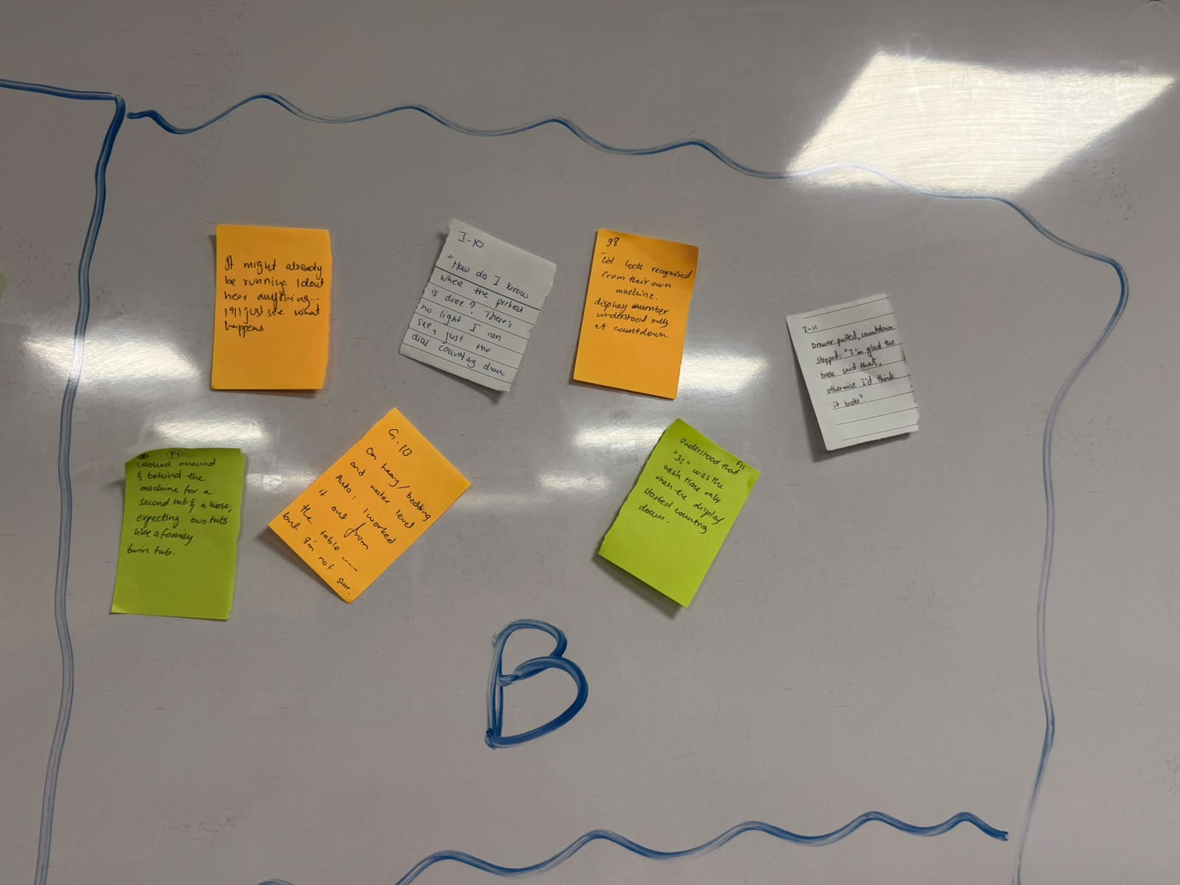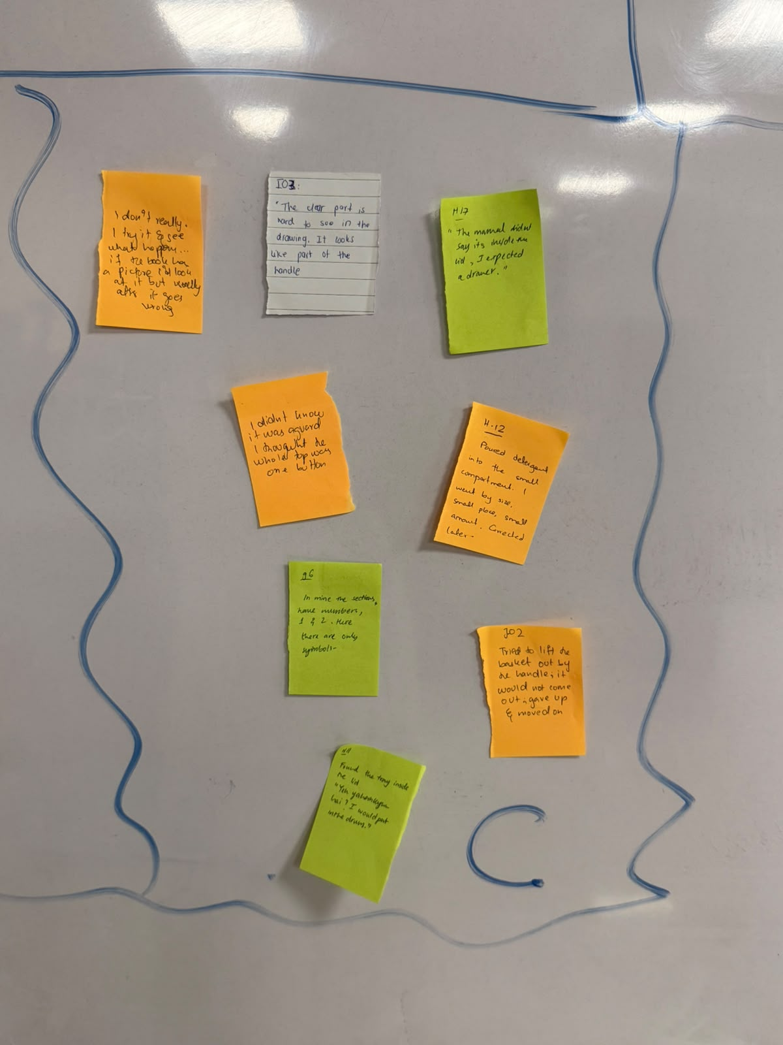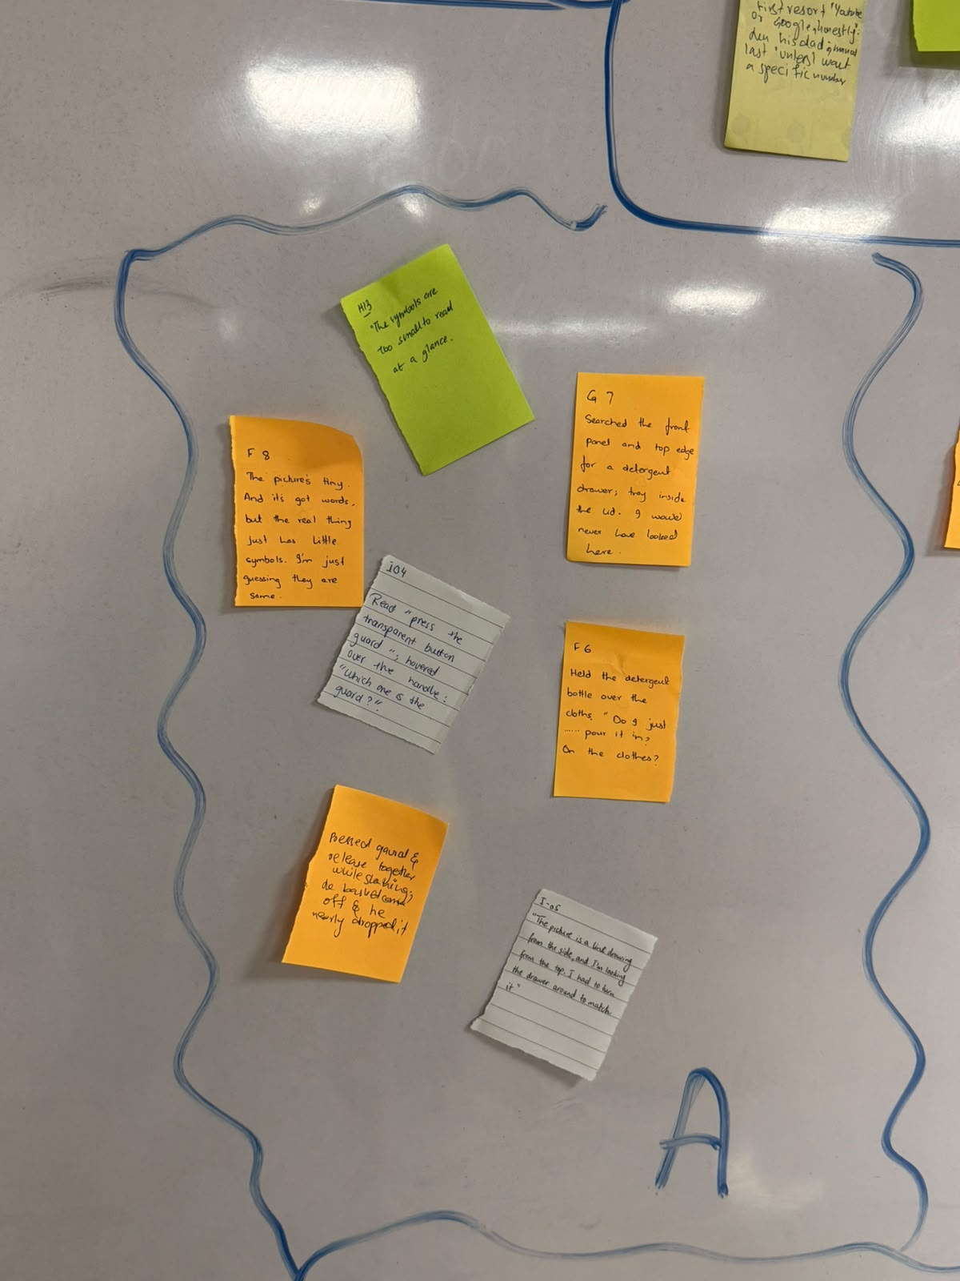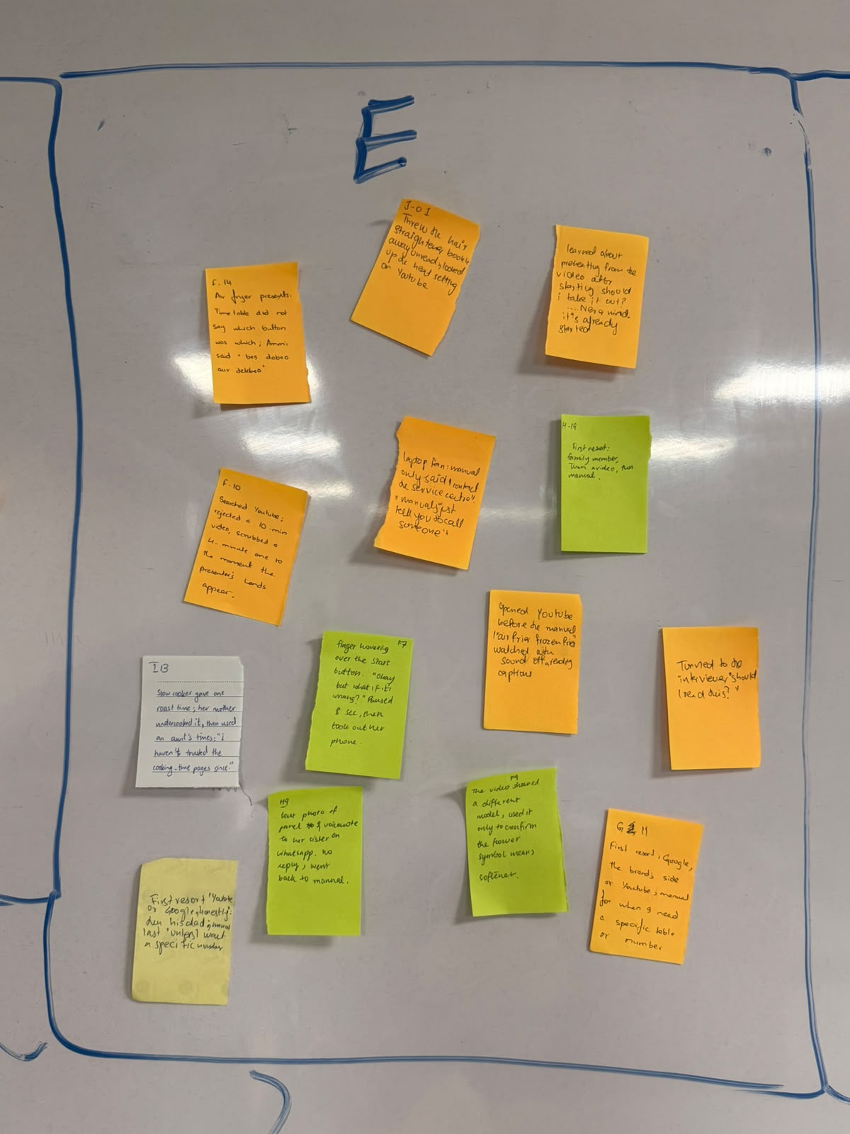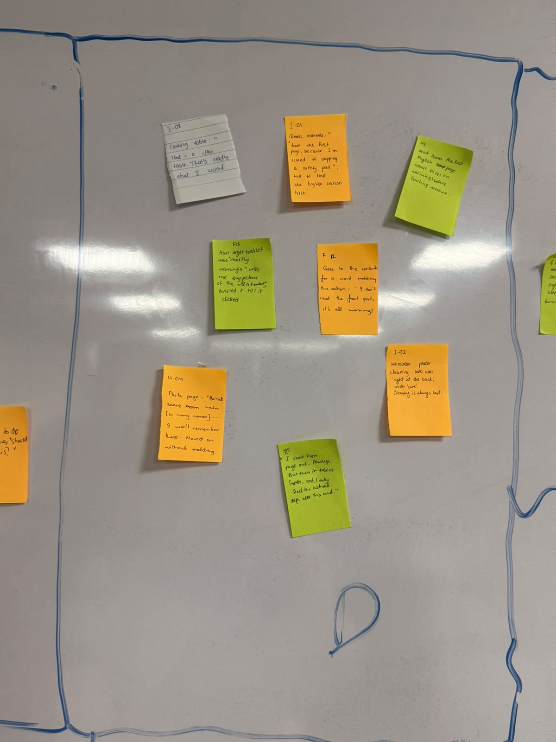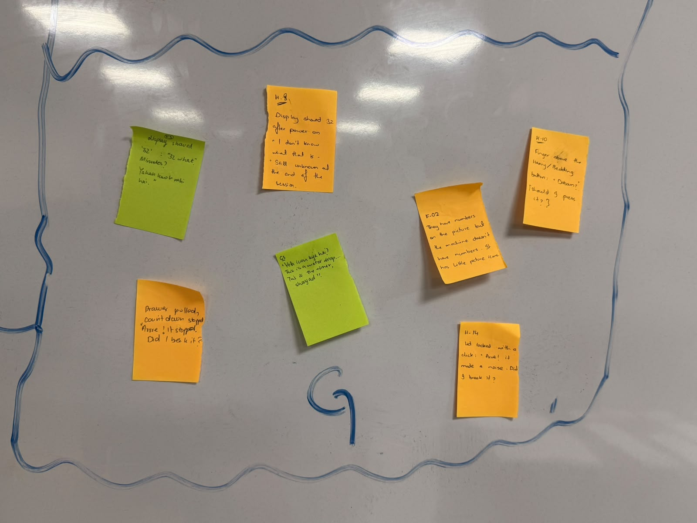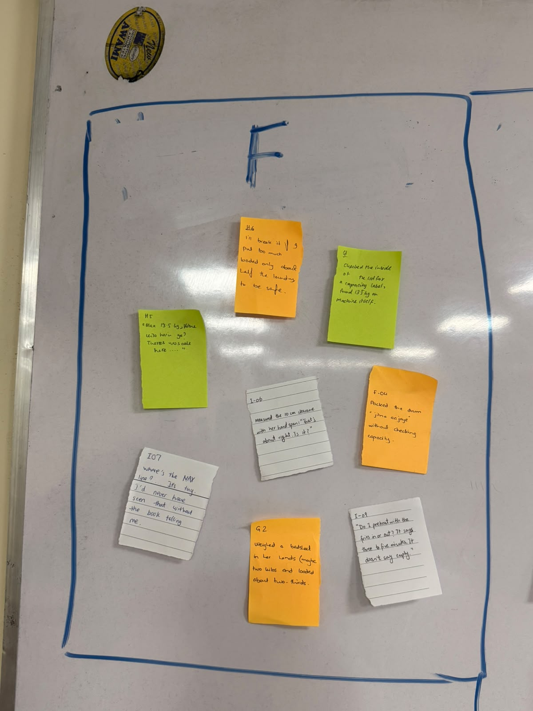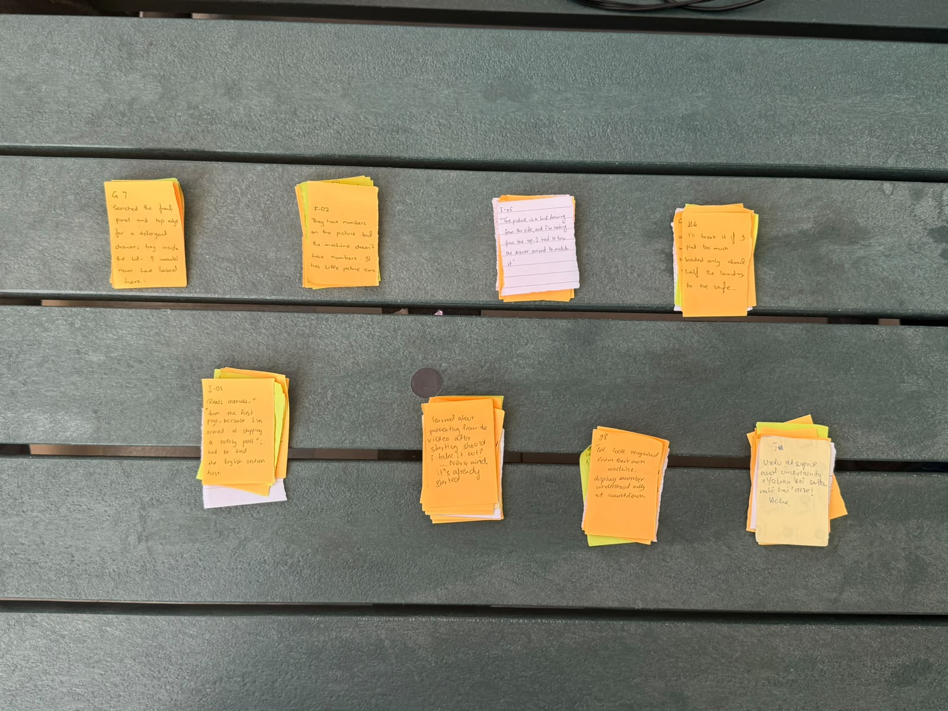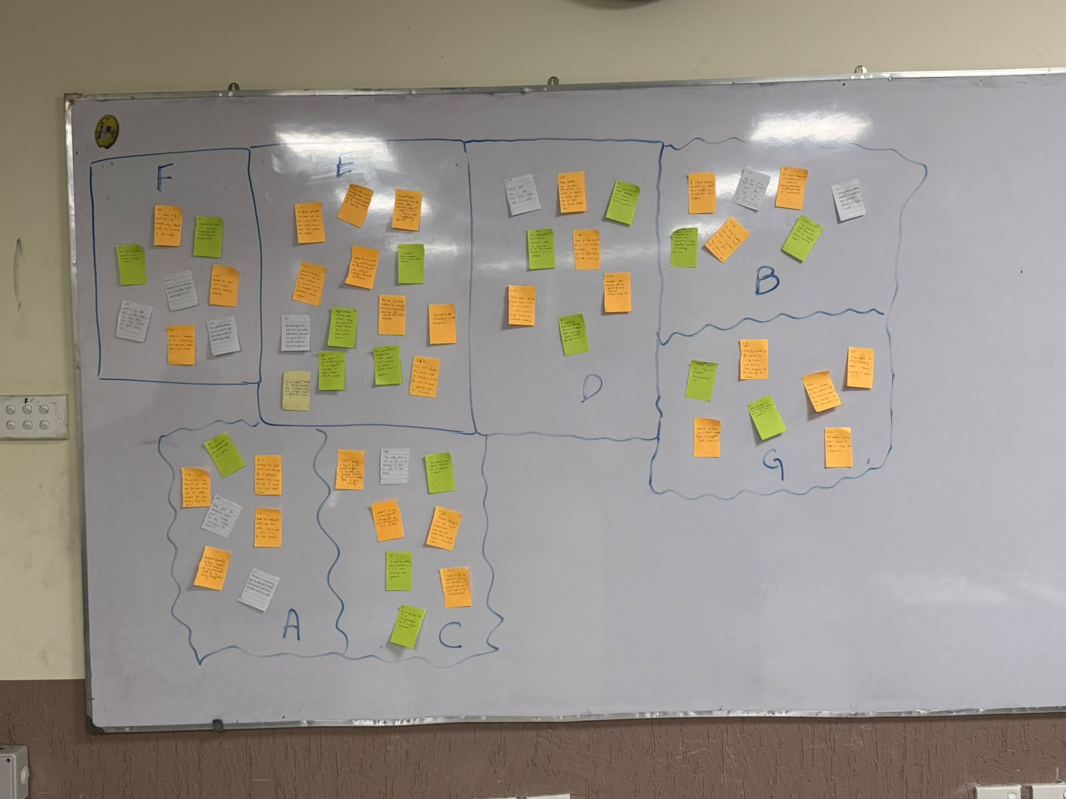
In the first pass we moved notes into piles quickly and in silence, putting a note next to another one if they "felt similar", without naming anything first. Every note was placed in one of the seven piles, even where the fit was loose, so that weak fits could be challenged in Stage 3. After the silent pass, we discussed each pile aloud and gave a temporary description of why its notes were together.
Pile | Notes | Why the notes were put together (our reasoning at the time)
A. Basket and button guard | 7 notes  F, H, G, I, J  H-13, G-07, F-08, I-04, F-06, J-07, I-05 | All air fryer basket notes: the guard, the release button, the near-drop. Grouped by component, like pile C.
B. Surprises | 7 notes  F, G, I, J  J-03, I-10, G-08, I-11, F-01, G-10, F-11 | Moments where the machine did something unexpected: lid lock, countdown pause, one tub.
C. Detergent tray problems | 8 notes  H, G, I, J  J-09, I-03, H-17, J-10, H-12, G-06, J-02, H-11 | Everything that happened at the detergent tray: finding it, the two compartments, the symbols. Grouped together because they all involve the same physical part.
D. Reading the manual | 8 notes  F, H, I  I-08, I-01, H-03, F-13, F-12, I-02, H-04, H-15 | How people moved through the booklet: page one, contents, tables, warnings, language sections.
E. Phone, video and family | 14 notes  F, H, G, I, J  F-14, J-01, J-05, H-19, F-10, J-11, I-13, F-07, J-04, J-08, H-09, F-09, G-11, J-12 | Every time someone reached outside the manual: YouTube, WhatsApp, Ammi, brother, Google, plus asking the interviewer.
F. Load and capacity | 8 notes  F, H, G, I  H-06, G-01, H-05, I-06, F-04, I-07, G-02, I-09 | How much to put in or how to prepare it: kg limit, MAX line, overfilling and under-filling, clearance around the unit, preheating with or without food.
G. Display, buttons and dials | 7 notes  F, H, G, J  F-03, H-08, H-10, F-02, G-03, J-06, H-14 | Notes about the control panel or dials: the "32", icons, program choice, the Heavy/Bedding button. Grouped by where on the machine the problem happened.

Stage 2 board. Each small square is one note from Stage 1 (same colour key). The full text of every note is in Appendix A.
Pile A: Basket and button guard
7 notes from participants F, H, G, I, J
Pile B: Surprises
7 notes from participants F, G, I, J
Pile C: Detergent tray problems
8 notes from participants H, G, I, J
Pile D: Reading the manual
8 notes from participants F, H, I
Pile E: Phone, video and family
14 notes from participants F, H, G, I, J
Pile F: Load and capacity
8 notes from participants F, H, G, I
Pile G: Display, buttons and dials
7 notes from participants F, H, G, J

What we noticed at the end of Stage 2
At the end of Stage 2, we noticed that our silent pass had grouped notes by physical machine parts and surface topics rather than by underlying user experience patterns.
Component silos hid cross-appliance patterns. Separating pile A (air fryer basket and guard) from pile C (washing machine detergent tray) hid the fact that users on both appliances were struggling with the same problem: locating and operating a critical physical part whose design or illustration clashed with their expectations. Even within piles A and C, notes from both appliances had already started bleeding into each other during the silent pass (H-13, G-07, F-08, F-06 in pile A; I-03 in pile C), showing that component boundaries were not holding.
Surface piles mixed causes and effects. Pile G (Display, buttons and dials) grouped notes by where the user was looking on the machine, while pile B (Surprises) grouped notes by how the user reacted. Both piles captured the same breakdown: users misinterpreting or doubting the machine's state and feedback signals (the "32", the lid-lock click, a silent air-fryer dial).
Non-actionable labels. Knowing that "things went wrong at the detergent tray" or "on the display" only told us where a breakdown happened, not why the manual and machine failed to guide the user.
Stage 3. Regrouping: notes moved, split and merged
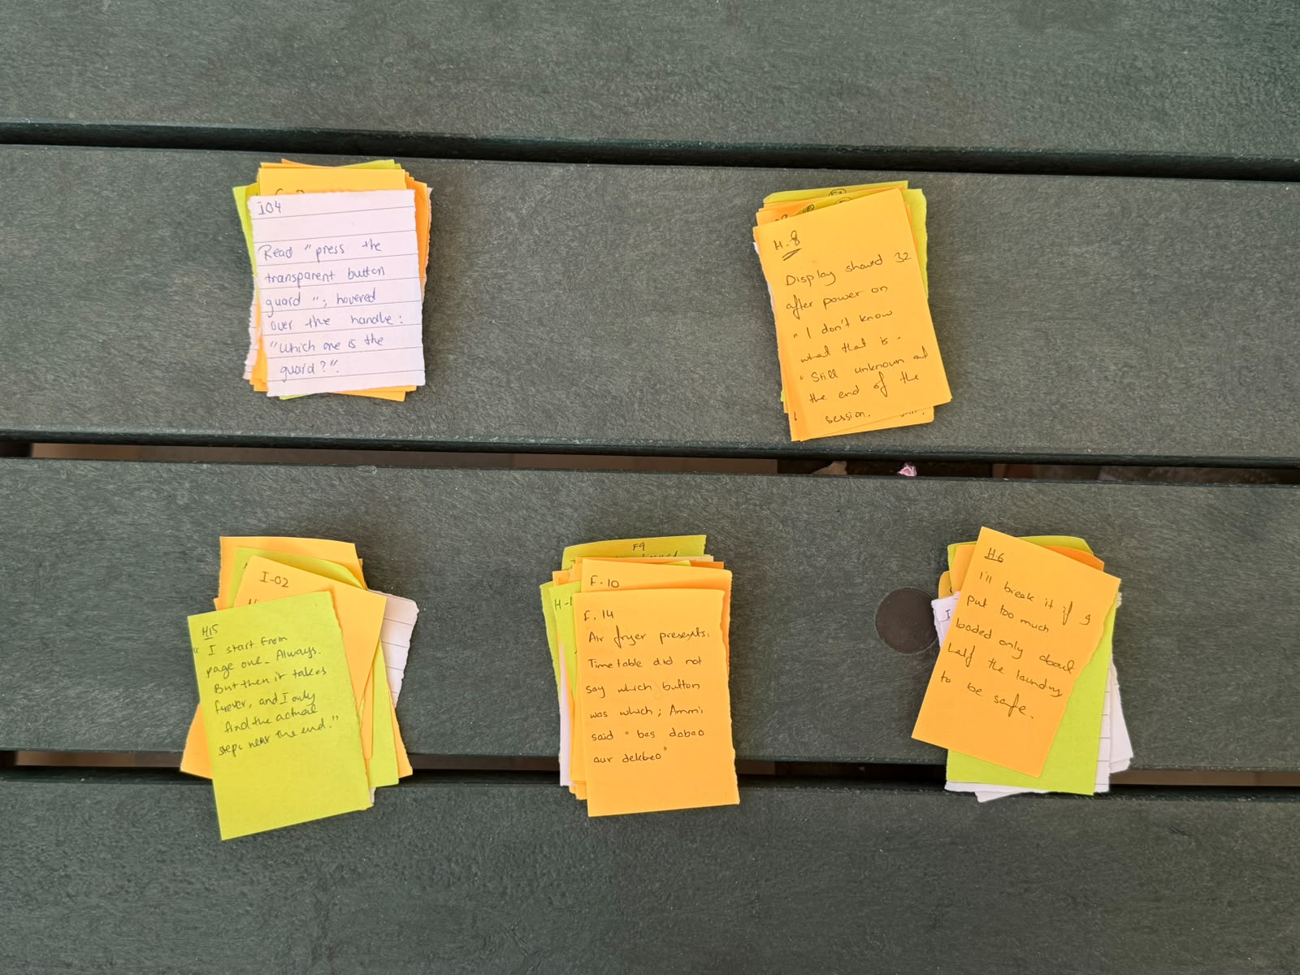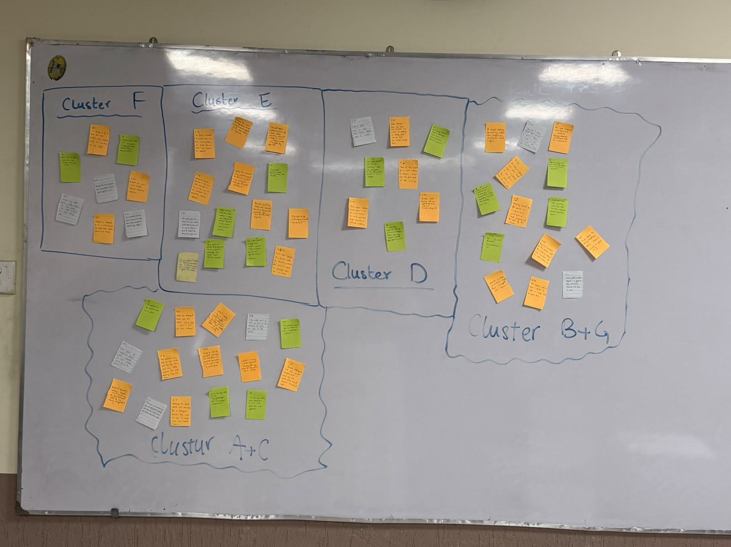

In Stage 3 we re-argued every pile. The table records each move as it appears in the Stage 3 photo; the full note-by-note movement is in the Final affinity diagram tables below.
# | Move | Notes moved and where to | Reasoning
M1 | Split pile A with C | Pile A (7 notes: H-13, G-07, F-08, I-04, F-06, J-07, I-05) placed together with pile C to form cluster A+C (15 notes). | Both piles described the same behavioural breakdown across the two appliances: users failing to locate, recognise or distinguish a physical part at the moment of action (G-07, H-17, I-04, J-10). Whether searching for a detergent tray hidden inside the lid, guessing which compartment takes main-wash detergent (H-12, G-06, F-08), or failing to spot the transparent button guard (I-03, I-05, J-02, J-07), users were blocked because the part was hidden where prior habits taught them not to look, or drawn from an angle or style that did not match the real hardware. Dissolving pile C into A+C created one cross-appliance cluster of 15 notes.
M2 | Dissolve pile C | All 8 pile C notes (J-09, I-03, H-17, J-10, H-12, G-06, J-02, H-11) moved into cluster A+C; pile C no longer exists. | Same reasoning as M1: once A and C were together, every C note belonged to the shared pattern, so pile C was dissolved into A+C.
M3 | Merge pile B with  G | Pile B (7 notes: J-03, I-10, G-08, I-11, F-01, G-10, F-11) placed together with pile G to form cluster B+G (14 notes). | Separating "panel icons and numbers" from "unexpected machine behaviours" was an artificial split. F-03 and H-08 (not knowing what "32" meant) were in pile G, while F-11 and G-08 (realising "32" was the wash time only at countdown) were in pile B. H-14 and J-06 (alarm at the lid lock or drawer pause) were in pile G, while I-11 (the same drawer-pause event) was in pile B. Merging B and G united all 14 notes where the appliance's visual, audible or mechanical signals failed to communicate its state, so users hesitated or mistook normal operation for a fault.
M4 | dissolve pile G | All 7 pile G notes (F-03, H-08, H-10, F-02, G-03, J-06, H-14) moved into cluster B+G; pile G no longer exists. | Same reasoning as M3: every G note belonged to the shared state-and-feedback pattern, so pile G was dissolved into B+G.
M5 | Same pile D (reading the manual) | No notes moved. Pile D keeps its 8 notes (I-08, I-01, H-03, F-13, F-12, I-02, H-04, H-15). | All 8 notes in pile D already captured a coherent, cross-appliance pattern rather than a machine component: the friction of navigating the booklet itself (multi-language sections, front-loaded warnings and unmapped parts lists before the actionable steps).
M6 | Same pile E | No notes moved. Pile E keeps its 14 notes (F-14, J-01, J-05, H-19, F-10, J-11, I-13, F-07, J-04, J-08, H-09, F-09, G-11, J-12). | All 14 notes in pile E already shared one clear pattern across all five participants and both appliances: bypassing or abandoning the printed manual for faster, higher-trust reassurance (YouTube, Google, WhatsApp, family members or the interviewer).
M7 | Kept pile F (load and capacity) | No notes moved. Pile F keeps its 8 notes (H-06, G-01, H-05, I-06, F-04, I-07, G-02, I-09). | No note was removed. All 8 notes already formed one pattern across both appliances: users trying to translate numerical rules and preparation constraints in the manual (13.5 kg, 10 cm, MAX line, 3-5 min preheat) into physical checks at the machine.

Disagreements and outliers discussed during regrouping
# | Question raised | Positions in the discussion | Resolution and why
D1 | Should the washing machine detergent tray (pile C) and the air fryer basket guard (pile A) stay separate? | Keep separate: they are different mechanical parts, one about pouring liquid into compartments (H-12, G-06), the other a safety latch (I-04, J-07).  Merge: keeping them separate groups by machine part; in both cases users failed because a critical part was not where they expected or did not look like the drawing (G-07, I-05). | Merged into cluster A+C (T1). Grouping by the underlying breakdown (failing to map named parts to the hardware) made the theme true across both appliances.
D2 | Where do the panel icon and button-guessing notes (F-02, G-03, H-10, G-10) belong: T1 (Can't find part) or T2 (Machine signal misread)? | T1: F-02 and G-03 are about matching symbols on the machine to the manual, like F-08 and G-06 at the detergent tray.  T2: on the control panel, icons and button states work alongside the "32" display (F-03, H-08) as the signals the user reads to work out what the machine is doing before pressing Start. | Kept in cluster B+G (T2). Compartment and part identification (F-08, G-06) stays in T1; control-panel state, icon decoding and feedback interpretation (F-02, G-03, H-10, G-10) go in T2, because they drive hesitation over how the machine will behave when started.
D3 | Does I-09 ("Do I preheat with the fries in or out?") belong in pile F (T4) or pile D (T5)? | T5: it is a missing detail in the written steps.  T4: she found the number (3 to 5 minutes) right away, so it was not buried; she could not act on it because the condition (empty or loaded) was not specified. | Kept in cluster F (T4). Like 13.5 kg (H-05) or 10 cm (I-06), the manual gave a precise quantity without the practical context needed to carry it out.
D4 | Should positive notes (I-08 clear cooking table, I-11 manual prevented panic, G-01 found the 13.5 kg label) be removed because they are not breakdowns? | Remove: clusters should highlight pain points.  Keep: they show when and why the manual succeeds. I-08 shows users value scannable tables once they reach them (T5); I-11 shows that warning users about normal stops prevents panic, as counter-evidence to J-06 (T2); G-01 and G-02 show that even with the number, she still had to guess weight by hand (T4). | Kept all three in their clusters (I-08 in T5, I-11 in T2, G-01 in T4). Counter-evidence shows what separates a successful step from a breakdown.
D5 | Should page-one readers (H-03, H-15, I-01) and contents-skippers (F-12) be split into two clusters? | Split: their reading strategies are opposite.  Keep together: both respond to the same structure, warnings and parts lists at the front and the setup steps at the back. | Kept together (T5). Whether a user reads 60 seconds of warnings first (H-03) or skips the front entirely (F-12), both pay the cost of the steps being buried.

Stage 4. Naming: clusters named after the pattern became visible
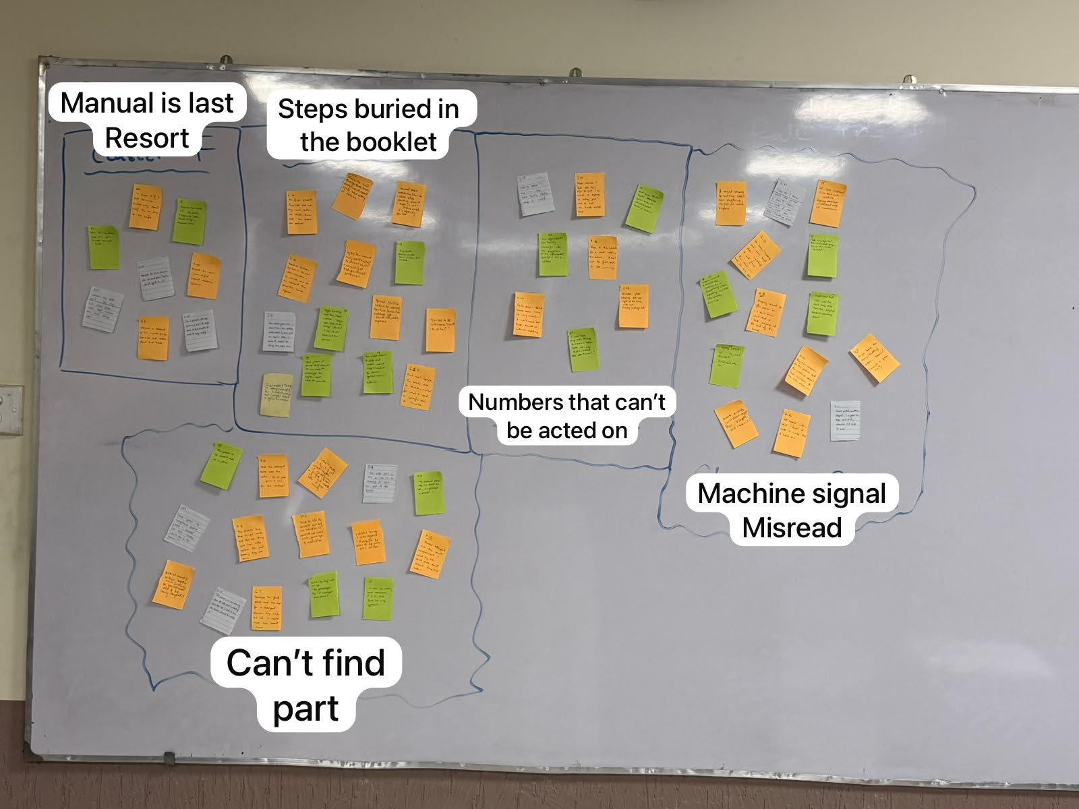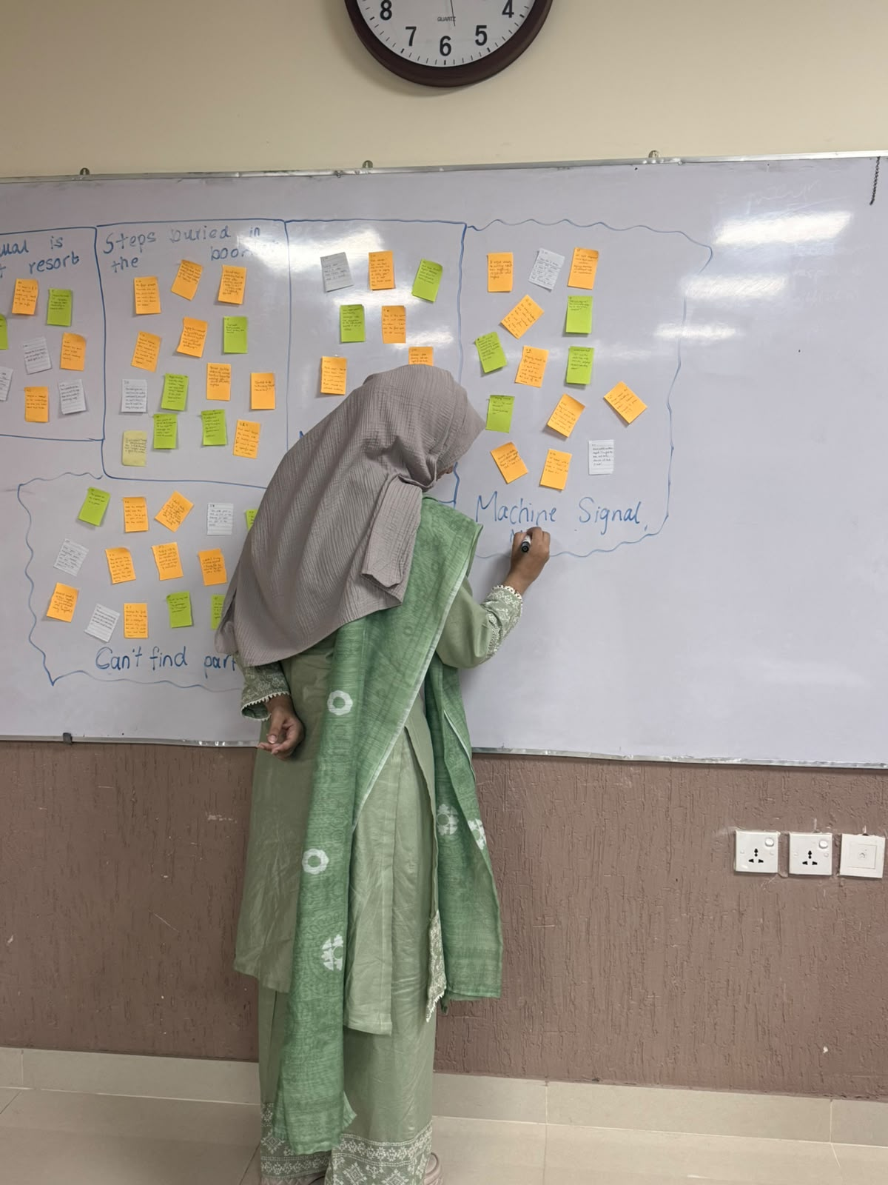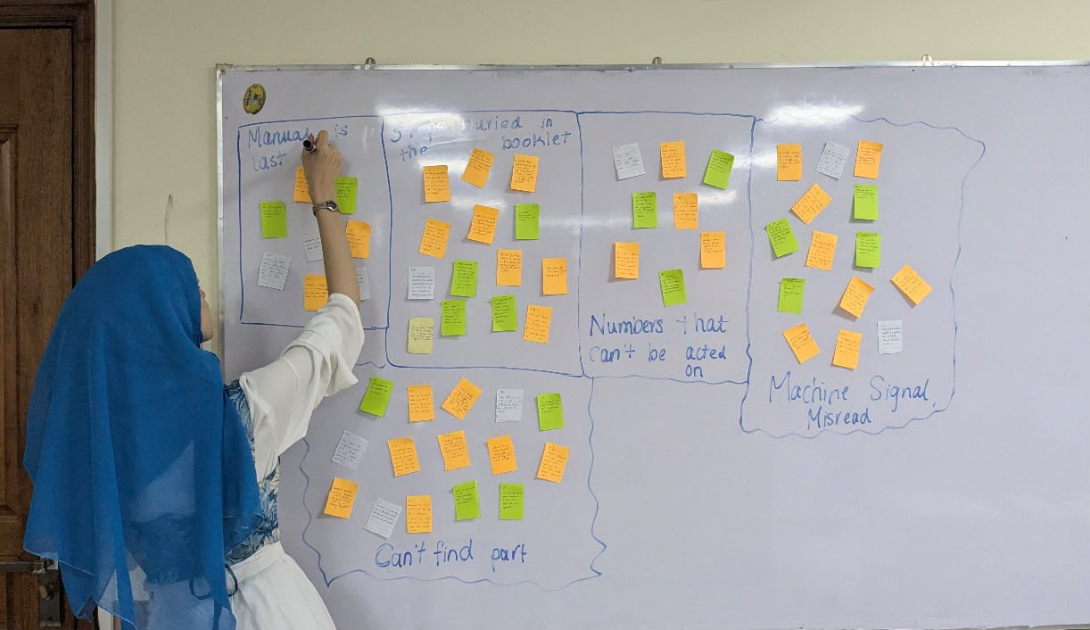
Note on the annotated photo: the first three labels in the top row sit one box to the left of the notes they describe. The correct pairing is: top-left box (pile F notes) = T4 Numbers that can't be acted on; second box (pile E notes) = T3 Manual is last resort; third box (pile D notes) = T5 Steps buried in the booklet. "Can't find part" (A+C) and "Machine signal misread" (B+G) are placed correctly.
We named clusters only after the regrouping had settled, and only once we could state the shared pattern in one sentence. Each name had to describe the users' experience (not a part of the machine or a solution) and had to be true for every note in the cluster. Rejected names are listed because they show why the final wording was chosen.
Code | Working label to final theme name | How the theme was identified (the pattern) | Spread | Names considered and rejected
T1 | Cluster A+C (Basket and button guard + Detergent tray problems) → Can't find part | Across both appliances, users could not locate or distinguish the physical part a step referred to, because it was hidden in an unexpected spot or drawn from an angle and labelling style that did not match the real hardware. | 15 notes; 5 of 5 participants (F, H, G, I, J); washing machine and air fryer | "Detergent tray and basket guard problems": only pasted two Stage 2 component labels together.  "Bad diagrams": blamed one medium and was not true for every note (F-06, G-07, J-02 happened at the machine before any diagram).
T2 | Cluster B+G (Surprises + Display, buttons and dials) → Machine signal misread | Users repeatedly hesitated over control-panel icons and misread the appliance's normal feedback (the "32" display, the lid-lock click, silent heating, the drawer timer pause) as mysteries or faults. | 14 notes; 5 of 5 participants (F, H, G, I, J); washing machine and air fryer | "Scared of breaking the machine": only some notes involved fear (H-14, J-06); others were calm confusion (F-03, H-08, I-10, J-03, G-03).  "Confusing display and sounds": the air fryer has no display and made no sound (J-03, I-10).
T3 | Cluster E (Phone, video and family) → Manual is last resort | Whenever users wanted to learn a step quickly or confirm they had not made a mistake before starting, they bypassed or abandoned the booklet for YouTube, Google or family. | 14 notes; 5 of 5 participants (F, H, G, I, J); washing machine and air fryer | "Using YouTube and family": listed channels, not the manual's role.  "Nobody reads the manual": false; 4 of 5 read it, and G-11 and J-12 keep it for specific tables or numbers.
T4 | Cluster F (Load and capacity) → Numbers that can't be acted on | Even when users found the exact figures in the manual (13.5 kg, 10 cm, MAX line, 3-5 min), they had to guess or improvise because they had no practical way to measure or check them with their hands and eyes. | 8 notes; 4 of 5 participants (F, H, G, I); washing machine and air fryer | "Overfilling and underfilling": covered only drum loading (F-04, H-06, G-02), not clearance (I-06) or preheat (I-09).  "Missing measurements": the figures were printed; users could not turn them into action.
T5 | Cluster D (Reading the manual) → Steps buried in the booklet | Users who tried to use the manual had to wade through multi-language sections, front-loaded warnings and unmapped parts lists before reaching the setup steps and tables near the back. | 8 notes; 3 of 5 participants (F, H, I); washing machine and air fryer | "Too many warnings": missed the English section (I-01), the parts list (H-04) and cleaning at the back (I-02).  "Poor table of contents": implied a fix and ignored page-one readers (H-03, H-15, I-01).

Final affinity diagram
The completed board after Stage 4. Every sticky note holds one evidence unit with its participant ID and D1B source, so each theme can be traced back to the fieldwork. Themes are ordered by strength (number of participants, then number of notes).

T1. Can't find part: 15 notes, 5 of 5 participants (F, H, G, I, J); washing machine and air fryer; strong
Note | Evidence unit | D1B source
F-06 | Held the detergent bottle over the clothes: "Do I just... pour it in? On the clothes?" | D1B 4.3, 00:06:32
F-08 | "The picture's tiny. And it's got words, but the real thing just has little symbols. I'm just guessing they are the same." | D1B 4.3, 00:07:42 (probe)
H-11 | Found the tray inside the lid: "Yeh yahan kyun hai? [Why is it here?] I would put it in the drum." | D1B 4.4, 00:08:45
H-12 | Poured detergent into the small compartment: "I went by size, small place, small amount." Corrected later. | D1B 4.4, 00:08:45; 00:09:20
H-13 | "The symbols are too small to read at a glance." | D1B 4.4, 00:09:20 (probe)
H-17 | "The manual didn't say it's inside the lid, I expected a drawer." | D1B 4.4, Q5
G-06 | "In mine the sections have numbers, 1 and 2. Here there are only symbols." | D1B 4.5, 00:07:24
G-07 | Searched the front panel and top edge for a detergent drawer; the tray was inside the lid: "I would never have looked here." | D1B 4.5, 00:06:56
I-03 | "The clear part is hard to see in the drawing. It looks like part of the handle." | D1B 5.3, 00:03:25 (probe)
I-04 | Read "press the transparent button guard"; hovered over the handle: "Which one is the guard?" | D1B 5.3, 00:03:25
I-05 | "The picture is a line drawing from the side, and I'm looking from the top. I had to turn the drawer around to match it." | D1B 5.3, 00:03:25 (probe)
J-02 | Tried to lift the basket out by the handle; it would not come out; gave up and moved on. | D1B 5.4, 00:03:05
J-07 | Pressed the guard and the release together while shaking; the basket came off and he nearly dropped it. | D1B 5.4, 00:06:00
J-09 | "I don't, really. I try it and see what happens... if the book has a picture I'd look at it, but really after it goes wrong." | D1B 5.4, Q2
J-10 | "I didn't know it was a guard. I thought the whole top was one button." | D1B 5.4, Q4

T2. Machine signal misread: 14 notes, 5 of 5 participants (F, H, G, I, J); washing machine and air fryer; strong
Note | Evidence unit | D1B source
F-01 | Looked around and behind the machine for a second tub and a hose, expecting two tubs like the family twin-tub. | D1B 4.3, 00:03:37
F-02 | "They have numbers on the picture but the machine doesn't have numbers. It has little picture icons." | D1B 4.3, 00:04:12
F-03 | Display showed "32": "32 what? Minutes? Yahan knob nahi hai [there's no knob here]." | D1B 4.3, 00:04:54
F-11 | Understood that "32" was the wash time only when the display started counting down. | D1B 4.3, 00:09:55; Q4
H-08 | Display showed 32 after power on: "I don't know what that is." Still unknown at the end of the session. | D1B 4.4, 00:07:00; Q4
H-10 | Finger above the Heavy/Bedding button: "Dabaun? [Should I press it?]" | D1B 4.4, 00:08:24
H-14 | Lid locked with a click: "Arre! It made a noise. Did I break it?" | D1B 4.4, 00:09:55
G-03 | "Yeh icon kya hai? [What is this icon?] This is a water drop... this is the timer, shayad [maybe]." | D1B 4.5, 00:04:26
G-08 | Lid lock recognised from her own machine; display number understood only at the countdown. | D1B 4.5, 00:07:59
G-10 | "On Heavy/Bedding and water level Auto, I worked it out from the table... but I'm not sure." | D1B 4.5, Q4
I-10 | "How do I know when the preheat is done? There's no light I can see, just the dial counting down." | D1B 5.3, 00:06:35 (probe)
I-11 | Drawer pulled, countdown stopped: "I'm glad the book said that, otherwise I'd think it broke." | D1B 5.3, 00:07:10
J-03 | "It might already be running. I don't hear anything... I'll just see what happens." | D1B 5.4, 00:04:15 (probe)
J-06 | Drawer pulled, countdown stopped: "Arre! It stopped. Did I break it?" | D1B 5.4, 00:05:45

T3. Manual is last resort: 14 notes, 5 of 5 participants (F, H, G, I, J); washing machine and air fryer; strong
Note | Evidence unit | D1B source
F-07 | Finger hovering over the Start button: "Okay, but what if it's wrong?" Paused 8 seconds, then took out her phone. | D1B 4.3, 00:08:17
F-09 | The video showed a different model; used it only to confirm that the flower symbol means softener. | D1B 4.3, 00:09:34
F-10 | Searched YouTube; rejected a 10-minute video, scrubbed a 4-minute one to the moment the presenter's hands appear. | D1B 4.3, 00:08:31
F-14 | Air fryer presets: the time table did not say which button was which; Ammi said "bas dabao aur dekho" [just press and see]. | D1B 4.3, Q6
H-09 | Sent a photo of the panel and a voice note to her sister on WhatsApp; no reply; went back to the manual. | D1B 4.4, 00:07:21
H-19 | First resort: a family member, then a video, then the manual. | D1B 4.4, Q7
G-11 | First resort: Google, the brand's site or YouTube; the manual is "for when I need a specific table or number". | D1B 4.5, Q7
I-13 | Slow cooker gave one roast time; her mother undercooked it, then used an aunt's times: "I haven't trusted the cooking-time pages since." | D1B 5.3, Q6
J-01 | Threw the hair straightener booklet away unread; looked up the heat setting on YouTube. | D1B 5.4, Q1
J-04 | Opened YouTube before the manual ("air fryer frozen fries"); watched with the sound off, reading captions. | D1B 5.4, 00:05:10
J-05 | Learned about preheating from the video after starting: "Should I take it out?... Never mind, it's already started." | D1B 5.4, 00:05:10
J-08 | Turned to the interviewer: "Should I read this?" | D1B 5.4, 00:06:25
J-11 | Laptop fan: the manual only said "contact the service centre". "Manuals just tell you to call someone." | D1B 5.4, Q6
J-12 | First resort "YouTube or Google, honestly"; then his dad; the manual last "unless I want a specific number". | D1B 5.4, Q7

T4. Numbers that can't be acted on: 8 notes, 4 of 5 participants (F, H, G, I); washing machine and air fryer; supporting
Note | Evidence unit | D1B source
F-04 | Packed the drum "jitna aa jaye" [as much as fits] without checking capacity. | D1B 4.3, 00:05:36
H-05 | "Max 13.5 kg. Kitne kilo hain ye? [How many kilos is this?] There's no scale here..." | D1B 4.4, 00:05:29
H-06 | "I'll break it if I put too much." Loaded only about half the laundry to be safe. | D1B 4.4, 00:05:29 (probe)
G-01 | Checked the inside of the lid for a capacity label; found 13.5 kg on the machine itself. | D1B 4.5, 00:03:36
G-02 | Weighed a bedsheet in her hands ("maybe two kilos") and loaded about two-thirds. | D1B 4.5, 00:04:08
I-06 | Measured the 10 cm clearance with her hand span: "That's about right. Is it?" | D1B 5.3, 00:04:30
I-07 | "Where's the MAX line?... It's tiny. I'd never have seen that without the book telling me." | D1B 5.3, 00:05:40
I-09 | "Do I preheat with the fries in or out? It says three to five minutes. It doesn't say empty." | D1B 5.3, 00:06:35

T5. Steps buried in the booklet: 8 notes, 3 of 5 participants (F, H, I); washing machine and air fryer; supporting
Note | Evidence unit | D1B source
F-12 | Goes to the contents for a word matching the action: "I don't read the front part, it's all warnings." | D1B 4.3, Q3
F-13 | Hair dryer booklet was "mostly warnings" with one tiny picture of the attachment; twisted it till it clicked. | D1B 4.3, Q1
H-03 | Read from the first English page, about 60 seconds on warnings, before touching the machine. | D1B 4.4, 00:03:37
H-04 | Parts page: "Bohat saare naam hain [so many names]... I won't remember these." Moved on without matching. | D1B 4.4, 00:04:54
H-15 | "I start from page one. Always. But then it takes forever, and I only find the actual steps near the end." | D1B 4.4, Q3
I-01 | Reads manuals "from the first page, because I'm scared of skipping a safety part"; had to find the English section first. | D1B 5.3, Q1
I-02 | Microwave plate cleaning info was "right at the back, under 'care'. Cleaning is always last." | D1B 5.3, Q1
I-08 | Cooking table: "That's a clear table. That's exactly what I wanted." | D1B 5.3, 00:06:10

Stage 5. Ladder: from themes to insights to needs
In the final stage each named theme was laddered upwards. An insight says why the pattern happens (the tension or cause behind the notes), and a need says what users need as a result, phrased as an outcome, a verb rather than a noun, with no feature, device or medium in it. Each ladder below shows the theme, the insight and the need as boxes, with the reasoning we stated for each step and the solution check the need passed.
Ladder 1: T1. Can't find part
Theme T1: Can't find part (15 notes: H-13, G-07, F-08, I-04, F-06, J-07, I-05, J-09, I-03, H-17, J-10, H-12, G-06, J-02, H-11)
▼
Insight: Manuals identify parts using abstract numbering, tiny symbols or side-angle line drawings, while the physical appliance hides those parts in unexpected places or leaves them unlabelled, forcing users to guess when their prior appliance habits do not match the hardware.
▼
Need: users need to visually match every part and symbol named in a step directly to the physical appliance from the angle they are standing at, before they act.
Ladder step | Our Reasoning
Theme to insight | We asked why all five participants struggled to locate or use the detergent tray and basket guard (G-07, H-12, I-04, J-10). Comparing the manual quotes (F-08, I-03, I-05) with the hardware quotes (G-06, H-11, H-17) showed a two-sided gap: the manual shows parts from side views or with numbered labels that do not exist on the machine, while the machine hides parts (the in-lid tray, the clear guard) where users' mental models from front-loaders, twin-tubs or single-button handles do not expect them.
Insight to need | Errors happened at the moment of translating a named part to the physical object (detergent in the wrong slot, H-12; release pressed while shaking, J-07), so the outcome users need is visual and spatial alignment from their real viewing angle before acting.
Solution check | The need describes a perceptual outcome and names no medium, sticker, colour code, 3D diagram or AR overlay.
Ladder 2: T2. Machine signal misread
Theme T2: Machine signal misread (14 notes: J-03, I-10, G-08, I-11, F-01, G-10, F-11, F-03, H-08, H-10, F-02, G-03, J-06, H-14)
▼
Insight: The appliance gives cryptic or unannounced feedback during setup and start, such as an unexplained "32", sudden mechanical clicks, timer pauses or silent heating, without indicating whether that signal confirms normal progress or warns of a user error.
▼
Need: users need to know immediately whether the machine's current state and responses are normal operation or a fault, at the moment they happen.
Ladder step | Our Reasoning
Theme to insight | We looked across the 14 notes to see what linked "32" (F-03, H-08), the lid-lock click (H-14), the drawer pause (I-11, J-06) and silent air-fryer heating (I-10, J-03). In every case the machine changed state, or failed to signal a change, without self-explanatory feedback. The contrast between I-11 (reassured because the manual forewarned her) and J-06 / H-14 ("Did I break it?") showed that unannounced normal behaviour is indistinguishable from a breakdown to a first-timer.
Insight to need | Users either panicked (H-14, J-06) or waited until the countdown moved to understand the display (F-11, G-08), so they need immediate certainty about what a response means at the moment it occurs.
Solution check | The need states a cognitive outcome and prescribes no screen message, beep, warning label or manual callout.
Ladder 3: T3. Manual is last resort
Theme T3: Manual is last resort (14 notes: F-14, J-01, J-05, H-19, F-10, J-11, I-13, F-07, J-04, J-08, H-09, F-09, G-11, J-12)
▼
Insight: When users feel uncertain right before or during an action, the printed manual demands slow searching and mental translation without confirming that their specific setup is right, whereas a video or a family member shows hands-on proof in seconds.
▼
Need: users need to verify that their intended action is correct in seconds, with enough visual certainty that they do not have to leave the instructions to seek outside reassurance.
Ladder step | Our Reasoning
Theme to insight | We asked why 4 of 5 participants ranked YouTube, Google or family ahead of the manual (H-19, G-11, J-12), and why F paused with her finger over Start to scrub a video to the presenter's hands (F-07, F-10). Users reach for outside help at moments of high hesitation because the manual gives abstract rules or "call the service centre" (J-11), while a video or relative gives fast, concrete confirmation.
Insight to need | Outside help brings its own risks (a different model, F-09; no reply, H-09; preheat learned too late, J-05), so users need rapid, high-confidence verification at the point of action.
Solution check | The need specifies speed and certainty of verification and names no QR code, video link, quick-start card or hotline.
Ladder 4: T4. Numbers that can't be acted on
Theme T4: Numbers that can't be acted on (8 notes: H-06, G-01, H-05, I-06, F-04, I-07, G-02, I-09)
▼
Insight: Manuals express load limits, clearances and preparation rules as measurements (13.5 kg, 10 cm) or tiny unpainted marks (MAX) that users have no everyday way to measure at home, or omit whether the machine should be empty or loaded during timed preheating.
▼
Need: users need to judge physical quantities, clearances and preparation conditions accurately using only their eyes and everyday household items at hand.
Ladder step | Our Reasoning
Theme to insight | Comparing H-05 ("How many kilos is this? There's no scale here"), G-02 (weighing a bedsheet by hand), I-06 (10 cm by hand span), I-07 (tiny MAX line) and I-09 (preheat with fries in or out?) showed that knowing the number did not prevent under-filling (H-06) or overfilling (F-04). The tension is between engineering units on paper and the tool-free reality of a household task.
Insight to need | To act on limits safely without a scale or ruler, users need to judge capacity, space and preparation state through everyday visual or physical comparison.
Solution check | The need focuses on the user's capability and names no weight sensor, painted fill line or comparison chart.
Ladder 5: T5. Steps buried in the booklet
Theme T5: Steps buried in the booklet (8 notes: I-08, I-01, H-03, F-13, F-12, I-02, H-04, H-15)
▼
Insight: Manuals are organised around manufacturer and legal priorities, putting multiple languages, pages of generic safety warnings and unmapped parts lists at the front, which forces both page-one readers and lookup users to hunt through non-actionable pages before reaching the task steps.
▼
Need: users need to reach the exact sequence of actions for their current task immediately, whether they start from page one or scan for a specific step.
Ladder step | Our Reasoning
Theme to insight | Page-one readers (H-03, H-15, I-01: reading from page one for fear of skipping safety, then finding steps near the end) and lookup users (F-12: skipping the front because "it's all warnings") both showed that the booklet's front-to-back structure works against the task. I-08 ("That's a clear table. That's exactly what I wanted") showed that once users reach structured task information it works; the problem is everything burying it.
Insight to need | Users enter the manual with two different habits (reading from the start or looking up a step), so they need immediate access to the task sequence from either entry path.
Solution check | The need describes reaching the task sequence and names no tabs, quick-start sheet, index or separate language booklets.

1.2 Themes, insights and needs (summary of the strongest clusters)
Strength rule we set before ranking: a cluster is strong if it holds notes from at least four of the five participants and at least nine notes; otherwise it is supporting. Applying this rule, three clusters are strong (T1, T2, T3) and two are supporting (T4, T5).
We kept T4 and T5 as supporting themes for four reasons. First, traceability: discarding them would have dropped 16 of our 59 notes (27%) from the board. Second, both contain evidence from both appliances (washing machine F, H, G and air fryer I), so they are cross-appliance patterns rather than single-session flukes. Third, they explain breakdowns no other cluster covers: T4 the loading and preheat breakdowns (F-04, H-06, I-07, I-09) and T5 the navigation friction (H-03, H-15, F-12, I-01). Fourth, labelling them supporting keeps the weighting honest while primary ideation stays focused on T1 to T3.
Theme | Insight | Need | Key evidence
T1. Can't find part  (strong; 15 notes, 5 of 5) | Manuals identify parts using abstract numbering, tiny symbols or side-angle line drawings, while the physical appliance hides those parts in unexpected places or leaves them unlabelled, forcing users to guess when their prior appliance habits do not match the hardware. | Users need to visually match every part and symbol named in a step directly to the physical appliance from the angle they are standing at, before they act. | H-13, G-07, F-08, I-04, F-06, J-07, I-05, J-09, I-03, H-17, J-10, H-12, G-06, J-02, H-11
T2. Machine signal misread  (strong; 14 notes, 5 of 5) | The appliance gives cryptic or unannounced feedback during setup and start, such as an unexplained "32", sudden mechanical clicks, timer pauses or silent heating, without indicating whether that signal confirms normal progress or warns of a user error. | Users need to know immediately whether the machine's current state and responses are normal operation or a fault, at the moment they happen. | J-03, I-10, G-08, I-11, F-01, G-10, F-11, F-03, H-08, H-10, F-02, G-03, J-06, H-14
T3. Manual is last resort  (strong; 14 notes, 5 of 5) | When users feel uncertain right before or during an action, the printed manual demands slow searching and mental translation without confirming that their specific setup is right, whereas a video or a family member shows hands-on proof in seconds. | Users need to verify that their intended action is correct in seconds, with enough visual certainty that they do not have to leave the instructions to seek outside reassurance. | F-14, J-01, J-05, H-19, F-10, J-11, I-13, F-07, J-04, J-08, H-09, F-09, G-11, J-12
T4. Numbers that can't be acted on  (supporting; 8 notes, 4 of 5) | Manuals express load limits, clearances and preparation rules as measurements (13.5 kg, 10 cm) or tiny unpainted marks (MAX) that users have no everyday way to measure at home, or omit whether the machine should be empty or loaded during timed preheating. | Users need to judge physical quantities, clearances and preparation conditions accurately using only their eyes and everyday household items at hand. | H-06, G-01, H-05, I-06, F-04, I-07, G-02, I-09
T5. Steps buried in the booklet  (supporting; 8 notes, 3 of 5) | Manuals are organised around manufacturer and legal priorities, putting multiple languages, pages of generic safety warnings and unmapped parts lists at the front, which forces both page-one readers and lookup users to hunt through non-actionable pages before reaching the task steps. | Users need to reach the exact sequence of actions for their current task immediately, whether they start from page one or scan for a specific step. | I-08, I-01, H-03, F-13, F-12, I-02, H-04, H-15

1.3 Evidence-grounded personas
Participants split on when the manual enters the task, so we present three personas on one spectrum rather than a single composite. The table shows the evidence each persona is built from; every detail is from D1B, and no names, photos or ages are invented.

Dimension | H | I | F | G | J
Where they start | Manual first, from the first English page, about 60 s on warnings (H-03) | Manual first, from page one (I-01) | Walks round the machine, then contents (F-01, F-12) | Machine first: capacity label on the lid (G-01) | Tries the machine, then YouTube before the manual (J-02, J-04)
Experience with this type | Never operated any washer (Section 1 table) | Household owns the unit; never operated it (Section 1 table) | Family twin-tub; never ran an automatic machine (F-01) | Owns a front-loader (G-06, G-08) | Household owns the unit; never operated it (Section 1 table)
Checking a part (Q2) | "With the detergent I didn't do it, I just assumed" (D1B 4.4, Q2) | "The machine has no labels, only the drawing does, so I was matching by shape" (D1B 5.3, Q2) | "The picture and the machine didn't match, so I was just kind of guessing" (D1B 4.3, Q2) | "If it's the same shape in the same place, I trust it" (D1B 4.5, Q2) | "I try it and see what happens" (J-09)
First resort (Q7) | Family member, then a video, then the manual (H-19) | "The manual, if I can find it" (D1B 5.3, Q7) | "Ammi. Then YouTube, probably. The manual's like third." (D1B 4.3, Q7) | Google, the brand's site or YouTube (G-11) | "YouTube or Google, honestly"; then his dad (J-12)
Persona | A | A | B | B | C

Persona A: The Careful First-Timer (grounded in H and I)

Opens the manual before touching the machine and reads from page one, because guessing feels unsafe (H-03, I-01, H-15).
At a glance | Persona A: The Careful First-Timer, grounded in H and I
Goal | Finish the setup correctly without breaking anything or skipping a safety step (I-01, H-06).
Biggest struggles | The steps come late in the booklet (H-15); drawings show the part from a different angle than the one they see (I-05, I-03); limits are given in units they cannot measure (H-05, I-06).
Needs served | T1 (match named parts to the machine from their viewing angle), T5 (reach setup steps without wading through front-loaded warnings), T4 (judge kg and cm limits without measuring tools), T2 (know that the lid-lock click and "32" display are normal).

Attribute | What the evidence shows | Evidence
Who | H: 25-34, student, never operated any washer. I: 18-24, household owns the air fryer, never operated it. | Section 1 table
Experience | No hands-on experience with this type of appliance. | Section 1 table
How they start | Picks up the manual before touching the machine and reads from the first page. | H-03, I-01, H-15
How they check a part | Matches the drawing to the machine by shape, even turning the part to fit a side view; the parts page has too many names to match. | I-05, I-03, H-04
Goals | Not to skip "a safety part"; not to break the machine. | I-01, H-06
Frustrations | "It takes forever, and I only find the actual steps near the end"; symbols and the MAX line are too small. | H-15, H-13, I-07
Feelings | Afraid of breaking it: "I'll break it if I put too much"; startled by the lid lock; unsure even when right: "Is it?" | H-06, H-14, I-06
When stuck | H asks family, then a video (sister did not reply, so back to the manual). I stays with the manual, which reassured her about the drawer pause. | H-19, H-09, I-11
Typical mistake | Acting on a guess when the manual is silent: detergent poured into the small compartment "by size"; preheat with fries in or out left unresolved. | H-12, I-09, I-10

Persona B: The Lookup User (grounded in F and G)

Looks at the machine first and dips into the manual for one word, table or number (F-12, G-01, G-11).
At a glance | Persona B: The Lookup User, grounded in F and G
Goal | Get the machine running on the right setting quickly, using the manual only for a specific table or number (G-11, F-12).
Biggest struggles | The manual uses numbers and words where the machine has only icons (F-02, F-08, G-06); the display number is unexplained (F-03, F-11, G-08); the tray is not where they expect (G-07).
Needs served | T1 (match symbols and hidden compartments without guessing), T2 (understand what "32" and panel icons mean before the countdown), T3 (confirm a setup step in seconds without leaving for YouTube).

Attribute | What the evidence shows | Evidence
Who | F: 18-24, student, family uses a twin-tub. G: 25-34, postgraduate, runs her own household with a front-loader. | Section 1 table
Experience | Experienced with other machines and carries their habits over: a second tub, numbered compartments, a lid lock. | F-01, G-06, G-08
How they start | Looks at the machine first (walks round it, checks the lid label), then goes to the contents for a matching word. | F-01, G-01, F-12
How they check a part | Compares picture and machine and guesses when they differ. | F-08, F-02, G-03
Goals | "A specific table or number" from the manual, nothing more. | G-11
Frustrations | "They have numbers on the picture but the machine doesn't"; "Here there are only symbols"; "32 what?" | F-02, G-06, F-03
Feelings | Unsure before committing: "what if it's wrong?"; "I'm not sure". | F-07, G-10
When stuck | F goes to YouTube before pressing Start; G's first resort is Google, the brand's site or YouTube. | F-07, F-10, F-09, G-11
Typical mistake | Loading by habit or estimate instead of the stated limit: packed the drum "as much as fits"; loaded two-thirds by hand-weighing. | F-04, G-02

Persona C: The Try-First Fixer (grounded in J)

Tries the machine first and opens the manual only after something goes wrong (J-09, J-04).
At a glance | Persona C: The Try-First Fixer, grounded in J
Goal | Get the food cooking without reading, looking up only a specific number when needed (J-09, J-12).
Biggest struggles | Did not recognise the button guard, so the basket seemed stuck (J-10, J-02); could not tell whether the unit was running (J-03); learned about preheating too late (J-05).
Needs served | T1 (recognise the button guard and release button at first touch), T2 (know when the unit is running and that the drawer pause is normal), T3 (get immediate confirmation before acting, so steps like preheating are not discovered too late).

Attribute | What the evidence shows | Evidence
Who | J: 18-24, student; household owns the air fryer; never operated it. | Section 1 table
Experience | Throws manuals away unread and uses YouTube instead. | J-01
How they start | Tries the basket first, then opens YouTube before the manual. | J-02, J-04
How they check a part | Does not check first; looks at the picture "after it goes wrong". | J-09, J-10
Goals | The manual only "if I want a specific number". | J-12
Frustrations | "Manuals just tell you to call someone." | J-11
Feelings | Casual, then startled: "I'll just see what happens"; "Did I break it?" | J-03, J-06
When stuck | YouTube or Google, then his dad; asked the interviewer "Should I read this?" | J-12, J-08
Typical mistake | Doing the cautioned action: pressed the guard and release together while shaking and nearly dropped the basket; skipped preheat. | J-07, J-05

1.4 Journey map of the core task

Stage | 1. Orient | 2. Find the instructions | 3. Identify parts and controls | 4. Load and configure | 5. Start and interpret | 6. Check and recover
Actions | H and I open the manual at page one (H-03, I-01); F walks round looking for a second tub (F-01); G checks the lid for capacity (G-01); J tries to lift the basket out (J-02) | F goes to the contents for a matching word (F-12); H reads in page order (H-15); H skims the parts page (H-04); J opens YouTube first (J-04) and asks the interviewer (J-08) | Compare picture and panel (F-02, G-03); turn the drawer to match a side view (I-05); look for the guard (I-04); search the front and top for a detergent drawer (G-07) | F packs the drum (F-04); H loads half (H-06); G weighs by hand, loads two-thirds (G-02); I hand-spans the clearance (I-06); detergent held over clothes (F-06) or poured in the small compartment (H-12); G sets Heavy/Bedding, water level Auto (G-10) | Finger over Start or the program button (F-07, H-10); lid locks (H-14, G-08); drawer pulled, timer pauses (I-11, J-06); display shows 32 (H-08, F-11) | YouTube (F-10, F-09, J-05); WhatsApp to sister (H-09); compartment corrected later (H-12); basket nearly dropped while shaking (J-07)
Thoughts | "I try it and see what happens" (J-09) | "I only find the actual steps near the end" (H-15); "Should I read this?" (J-08) | "Which one is the guard?" (I-04); "Why is it here?" (H-11); "32 what? Minutes?" (F-03) | "How many kilos is this?" (H-05); "Do I preheat with the fries in or out?" (I-09) | "Did I break it?" (H-14, J-06); "It might already be running" (J-03); "How do I know when the preheat is done?" (I-10) | "What if it's wrong?" (F-07); "Never mind, it's already started" (J-05)
Emotions | Cautious: "scared of skipping a safety part" (I-01) | Relief at a clear table (I-08); impatience: "it takes forever" (H-15) | Guessing: "I'm just guessing they are the same" (F-08); "shayad" [maybe] (G-03) | Fear: "I'll break it if I put too much" (H-06); unsure (G-10, I-06) | Hesitation (F-07, H-10); startled (H-14, J-06); relief when the manual had warned her (I-11) | Uncertain; partial reassurance from a video of a different model (F-09)
Pain points | Front pages are warnings: some skip them (F-12), others read them first (H-03); expects a second tub (F-01) | Steps sit late (H-15); cleaning is "always last" (I-02); English section must be found first (I-01); parts names not linked to the machine (H-04) | Numbers in the manual, icons on the machine (F-02, G-06); side view vs top view (I-05); clear guard invisible in the drawing (I-03); symbols too small (H-13); tray hidden in the lid (G-07, H-17) | Limits in units users cannot measure (H-05, I-06); MAX line tiny (I-07); manual does not say whether to preheat empty (I-09) | Normal responses read as faults (H-14, J-06); display number understood only on countdown, or never (F-11, G-08, H-08); no "preheat done" signal (I-10) | Video shows a different model (F-09); sister does not reply (H-09); preheat learned too late (J-05); near-drop (J-07)
Opportunities (as needs) | Need to reach the actionable setup sequence immediately, whether starting at page one or at the machine (T5, T1). | Need to reach the exact sequence of actions for the current task immediately, without wading through warnings or other languages (T5, T3). | Need to visually match every part and symbol named in a step to the physical appliance from the angle the user is standing at (T1). | Need to judge quantities, clearances and preparation conditions accurately using only eyes and everyday household items (T4). | Need to know immediately whether the machine's state and responses (lid lock, "32", drawer pause) are normal operation or a fault (T2). | Need to verify in seconds that an intended action is correct, with enough certainty that outside videos or family help are not needed (T3, T1).

Part 2. Problem framing

2.1 Hierarchical task analysis (two levels) of the core task
The HTA decomposes the core task into the goal (0), six sub-goals (1-6) and their actions (level 2), with a plan at each level. Because both appliances were observed, Plan 0 gives the order for each: on the air fryer, preheating (5) comes before loading (4). The table after the diagram adds, for every action, what actually happened in D1B and the need it relates to, so the HTA can be used to find where breakdowns concentrate.

HTA in tabular form, with observed breakdowns from D1B
No. | Sub-goal / action | Plan or what happened in D1B (evidence) | Need
0 | Set up and start an unfamiliar appliance for its first task, using its printed manual | Plan 0. Washing machine: 1, 2, 3, 4, 5, 6. Air fryer: 1, 2, 3, 5, 4, 6 (preheat before loading). | T1, T2, T3, T4, T5
1 | Find the instructions | Plan 1: 1.1, then 1.2. | T3, T5
1.1 | Find the English section | I had to find the English section first (I-01); H read about 60 s of warnings before touching the machine (H-03). | T5
1.2 | Find the set-up steps | F used the contents for a matching word (F-12); H found the steps "near the end" (H-15); J opened YouTube before the manual (J-04). | T5, T3
2 | Identify parts and controls | Plan 2: for each part a step names, do 2.1 and 2.2. | T1, T2
2.1 | Match the drawing to the machine | Parts page not matched (H-04); side-view drawing, drawer turned to fit (I-05); clear guard invisible in the drawing (I-03); "Which one is the guard?" (I-04). | T1
2.2 | Read symbols, icons and the display | Numbers in the manual, icons on the machine (F-02); icon guessed (G-03); symbols too small (H-13); "32" unexplained (F-03, H-08). | T1, T2
3 | Prepare the appliance | Plan 3. Washing machine: 3.1, then 3.2. Air fryer: 3.4, then 3.3. | T1, T4
3.1 | Washing machine: locate the detergent tray | Searched the front and top for a drawer; tray was inside the lid (G-07, H-11, H-17). | T1
3.2 | Washing machine: choose the compartment and add detergent | Held the bottle over the clothes (F-06); poured into the small compartment, corrected later (H-12); expected numbered sections (G-06). | T1
3.3 | Air fryer: remove the inner basket (lift the guard, press release) | Basket would not come out; gave up (J-02); "thought the whole top was one button" (J-10). | T1
3.4 | Air fryer: place the unit with 10 cm clearance | Measured with her hand span: "Is it?" (I-06). | T4
4 | Load | Plan 4: 4.1, then 4.2. | T4
4.1 | Judge the amount against the limit | "How many kilos is this?" (H-05); found 13.5 kg on the lid (G-01); MAX line "tiny" (I-07). | T4
4.2 | Load | Packed "as much as fits" (F-04); half "to be safe" (H-06); two-thirds by hand-weighing (G-02). | T4
5 | Set the controls | Plan 5. Washing machine: 5.1, then 5.2. Air fryer: 5.3, then 5.4. | T2, T4
5.1 | Washing machine: power on and read the display | "32 what? Minutes?" (F-03); still unknown at the end of the session (H-08). | T2
5.2 | Washing machine: select Heavy/Bedding, water level Auto | "Dabaun?" [Should I press it?] (H-10); "I'm not sure" (G-10). | T2
5.3 | Air fryer: set temperature and time | "It might already be running. I don't hear anything" (J-03). | T2
5.4 | Air fryer: preheat empty for 3 to 5 minutes | Fries in or out? (I-09); no "done" signal (I-10); J skipped it and learned about it from a video after starting (J-05). | T4, T2
6 | Start and interpret | Plan 6: 6.1, then 6.2; on the air fryer, 6.3 at about half time. | T1, T2, T3
6.1 | Press Start | Hovered over Start, then took out her phone (F-07); hesitated over the program button (H-10). | T3
6.2 | Interpret the lid lock, countdown and drawer pause | "Did I break it?" (H-14, J-06); "32" understood only at countdown (F-11, G-08); "I'm glad the book said that" (I-11). | T2
6.3 | Air fryer: shake without pressing the release | Pressed the guard and release together while shaking; near-drop (J-07). | T1
Plans are given in the table above. Sub-goals 2 to 6 are shared by both appliances; where an action applies to only one appliance it is named in the action.

What the HTA shows
Every sub-goal has at least one observed breakdown. They concentrate where the user has to match the manual to the machine: sub-goals 2 (identify parts and controls, 9 note references) and 3 (prepare the appliance, 9). Load (4) and set the controls (5) follow, with 6 and 8 references, where the manual gives a limit or a setting but not a way to check it. Sub-goal 6 (8) is where normal machine responses were read as faults and where the one safety event happened (J-07). Sub-goal 1 (5) is where the page-one reader and the lookup user part ways: one reads warnings first, the other jumps to the contents. The breakdowns appear on both appliances at the same sub-goals, which is why the themes span both.

2.2 Point-of-view (POV) statements
Each POV follows "[User] needs [need] because [insight]". The user is a persona from Section 1.3; the need and the insight are copied word for word from the Stage 5 ladder, and the trace table under each POV shows exactly where each part came from. POV-1 is the primary problem statement; POV-2 and POV-3 cover the other strongest clusters for the second persona and for the machine-response problem.

POV-1: Persona A and the matching problem (T1)
POV-1 (primary): Persona A, the Careful First-Timer needs to visually match every part and symbol named in a step directly to the physical appliance from the angle they are standing at, before they act, because manuals identify parts using abstract numbering, tiny symbols or side-angle line drawings, while the physical appliance hides those parts in unexpected places or leaves them unlabelled, forcing users to guess when their prior appliance habits do not match the hardware.

POV part | Exact wording in the POV | Copied word-for-word from | Evidence behind it
User | Persona A, the Careful First-Timer | Section 1.3 (persona) | H-03, I-01, I-05, I-03, H-04 (Section 1.3)
Need | to visually match every part and symbol named in a step directly to the physical appliance from the angle they are standing at, before they act | Stage 5 ladder, T1 need | T1 notes: H-13, G-07, F-08, I-04, F-06, J-07, I-05, J-09, I-03, H-17, J-10, H-12, G-06, J-02, H-11
Insight | Manuals identify parts using abstract numbering, tiny symbols or side-angle line drawings, while the physical appliance hides those parts in unexpected places or leaves them unlabelled, forcing users to guess when their prior appliance habits do not match the hardware. | Stage 5 ladder, T1 insight | T1 notes: H-13, G-07, F-08, I-04, F-06, J-07, I-05, J-09, I-03, H-17, J-10, H-12, G-06, J-02, H-11

POV-2: Persona B and the outside-help problem (T3)
POV-2: Persona B, the Lookup User needs to verify that their intended action is correct in seconds, with enough visual certainty that they do not have to leave the instructions to seek outside reassurance, because when users feel uncertain right before or during an action, the printed manual demands slow searching and mental translation without confirming that their specific setup is right, whereas a video or a family member shows hands-on proof in seconds.

POV part | Exact wording in the POV | Copied word-for-word from | Evidence behind it
User | Persona B, the Lookup User | Section 1.3 (persona) | F-12, G-11, F-07, F-10, F-09 (Section 1.3)
Need | to verify that their intended action is correct in seconds, with enough visual certainty that they do not have to leave the instructions to seek outside reassurance | Stage 5 ladder, T3 need | T3 notes: F-14, J-01, J-05, H-19, F-10, J-11, I-13, F-07, J-04, J-08, H-09, F-09, G-11, J-12
Insight | When users feel uncertain right before or during an action, the printed manual demands slow searching and mental translation without confirming that their specific setup is right, whereas a video or a family member shows hands-on proof in seconds. | Stage 5 ladder, T3 insight | T3 notes: F-14, J-01, J-05, H-19, F-10, J-11, I-13, F-07, J-04, J-08, H-09, F-09, G-11, J-12

POV-3: The machine-response problem (T2)
POV-3: A first-time user at the moment of Start (Personas A, B and C) needs to know immediately whether the machine's current state and responses are normal operation or a fault, at the moment they happen, because the appliance gives cryptic or unannounced feedback during setup and start, such as an unexplained "32", sudden mechanical clicks, timer pauses or silent heating, without indicating whether that signal confirms normal progress or warns of a user error.

POV part | Exact wording in the POV | Copied word-for-word from | Evidence behind it
User | A first-time user at the moment of Start (Personas A, B and C) | Section 1.3 (persona) | H-14, J-06, I-11, F-11, G-08, H-08
Need | to know immediately whether the machine's current state and responses are normal operation or a fault, at the moment they happen | Stage 5 ladder, T2 need | T2 notes: J-03, I-10, G-08, I-11, F-01, G-10, F-11, F-03, H-08, H-10, F-02, G-03, J-06, H-14
Insight | The appliance gives cryptic or unannounced feedback during setup and start, such as an unexplained "32", sudden mechanical clicks, timer pauses or silent heating, without indicating whether that signal confirms normal progress or warns of a user error. | Stage 5 ladder, T2 insight | T2 notes: J-03, I-10, G-08, I-11, F-01, G-10, F-11, F-03, H-08, H-10, F-02, G-03, J-06, H-14

2.3 How-Might-We (HMW) questions
Each HMW was written from a POV and then checked against two failure modes named in the brief: being so broad that it gives no direction, or being so narrow that it is already a feature. As a test of openness, we listed at least three very different directions each question allows. These directions are only there to show the question is open; none of them has been chosen, and choosing is D3's job.
HMW | Question | From | Too broad? | Already a solution? | Open to several directions? (illustrations only, not chosen)
HMW-1 | How might we help a first-time user recognise each part the instructions name, from the angle they are actually looking at it? | POV-1 (T1) | No: limited to parts named in the set-up instructions. | No: names no medium or feature. | Words or marks on the machine itself; drawings from the user's viewpoint; a camera overlay on a phone; colour-matching between page and part.
HMW-2 | How might we help a first-time user tell a normal machine response from a fault at the moment it happens? | POV-3 (T2) | No: limited to the responses seen in D1B (lid lock, display number, drawer pause). | No: does not say how the user is told. | A "what happens next" note beside the Start step; a status message on the display; a label near the lid; a short sound or voice cue.
HMW-3 | How might we make the manual the quickest place to confirm a step, so users do not need to leave it for a video or a relative? | POV-2 (T3) | No: tied to confirming a step during set-up. | No: does not prescribe a format. | A one-page quick-start; a contents organised by task; a model-specific short video linked from the page; an "is this normal?" section.
HMW-4 | How might we turn the limits the manual states (13.5 kg, MAX line, 10 cm, preheat 3 to 5 minutes) into checks a user can do with what they have at hand? | T4 (supporting) | No: limited to the four limits seen in D1B. | No: does not name a tool. | Load guidance in everyday items; a more visible fill mark; a clearance guide on the packaging; a preheat "empty" reminder on the dial.

Calibration: HMW drafts that were rejected
Rejected draft | Problem | What we did instead
"How might we put a QR code on the appliance that links to a 1-minute setup video for that exact model?" (from POV-2 / T3) | Already a solution (too narrow): prescribes a technology (QR code) and a medium (video), leaving no room for D3 to explore print, on-machine or structural alternatives. | Reframed around the user outcome, making the instructions the fastest way to confirm a step: HMW-3.
"How might we make household appliances less scary and more intuitive for first-time users?" (from POV-3 / T2) | Too broad: gives D3 no direction and ignores what triggered fear in D1B (the lid-lock click, the "32" display, the drawer pause read as faults). | Anchored to the specific moment and breakdown: HMW-2.

Example of one HMW being refined
Draft | Wording | Check result
Draft 1 | "How might we make the manual clearer for first-time users?" | Failed (too broad): does not say what was unclear or which T1 breakdown is being solved; gives D3 no focus.
Draft 2 | "How might we replace the side-view line drawings in the manual with top-down colour photos and printed labels on the detergent tray and basket guard?" | Failed (already a solution): dictates the graphic style, the medium and the parts, locking D3 into one fix.
Final (HMW-1) | "How might we help a first-time user recognise each part the instructions name, from the angle they are actually looking at it?" | Passed: targets the T1 matching breakdown (I-05, I-03, G-07, F-08) but stays open to on-machine markings, viewpoint-matched drawings, colour-coding or phone overlays.

Part 3. Requirements

3.1 User stories
Each story is tied to one persona and to the evidence behind it. The "Checked by" column shows the requirement whose success criteria will tell us, in D5, whether the story has been met.
ID | Persona | User story | Evidence | Need / HMW | Checked by
US-1 | A: Careful First-Timer | As a careful first-timer who reads the manual before touching the machine, I want each part in the instructions to look the way it does from where I stand, so that I can find it on my first try without guessing. | I-05, I-03, H-04, H-11, H-17 | T1 / HMW-1 | R1, R5
US-2 | B: Lookup User | As a lookup user who jumps straight to the step I need, I want to reach that step and its numbers quickly, so that I do not leave the manual for YouTube or Google. | F-12, G-11, F-07, F-10, F-09 | T3, T5 / HMW-3 | R2, R4
US-3 | C: Try-First Fixer | As a try-first user, I want to know that a machine response is normal, and which actions are unsafe, before I act, so that I do not stop the cycle or drop the basket. | J-06, J-07, J-03, J-05 | T2 / HMW-2 | R3, R4

3.2 Measurable requirements
Five requirements are set out below. Each one says what must be true for users, not how a design should achieve it, and each has success criteria that can be tested in D5A/D5B with the same task protocol used in D1B. Every requirement gives its D1B baseline, meaning what happened in our fieldwork, so a later evaluation can show improvement against real numbers. The requirements cover usability (R1-R3), user experience (R4) and accessibility (R5).
Critical parts (used in R1 and R5): washing machine: main-wash compartment, softener compartment, program selector, Start/Pause; air fryer: transparent button guard, basket release button, MAX line, temperature dial vs timer dial.
ID | Category | Requirement (what must be true, not how)
R1 | Usability (effectiveness, learnability) | A first-time user must be able to identify each part, control and symbol named in the setup instructions correctly on the first attempt, without help.
R2 | Usability (efficiency) | A user must be able to reach the instruction for the step they are on quickly, whichever way they start reading.
R3 | Usability (error prevention and safety) | Users must carry out order-dependent steps in the correct order and must not perform any action the manufacturer cautions against.
R4 | User experience (confidence, trust, self-sufficiency) | Users must understand the machine's normal responses when they happen, and must be able to finish setup on their own, feeling confident that each step was right.
R5 | Accessibility (perceivable, understandable) | Critical markings, symbols and instructions must be perceivable and understandable regardless of print size, the user's eyesight and the language the user thinks in.

R1. Correct identification of parts and symbols
Field | R1
Category | Usability (effectiveness, learnability)
Requirement | A first-time user must be able to identify each part, control and symbol named in the setup instructions correctly on the first attempt, without help.
Success criteria (testable) | At least 4 of 5 participants identify every critical part on the first attempt, without help. 0 detergent pours into the wrong compartment. 0 attempts to remove the basket without first lifting the guard.
How it will be measured (D5A/D5B) | D5B think-aloud using the D1B task; the observer logs the first touch or point for each critical part from the video. D5A cognitive walkthrough of the same steps.
D1B baseline (what happened in fieldwork) | Washing machine: the tray was not where 3 of 3 expected it (G-07, H-11, H-17); 1 of 3 poured into the wrong compartment (H-12). Air fryer: 0 of 2 recognised the guard at the first attempt (I-04, J-10); the basket "would not come out" (J-02).
Evidence it traces back to | H-13, G-07, F-08, I-04, F-06, I-05, I-03, H-17, J-10, H-12, G-06, J-02, H-11
Traces to | T1 → POV-1 → HMW-1 → US-1

R2. Reaching the right instruction
Field | R2
Category | Usability (efficiency)
Requirement | A user must be able to reach the instruction for the step they are on quickly, whichever way they start reading.
Success criteria (testable) | Median time from opening the manual to the instruction for the current step is 60 s or less, for both page-one readers and lookup users, with no more than 3 page turns.
How it will be measured (D5A/D5B) | Timestamps and page-turn counts from the D5B session video.
D1B baseline (what happened in fieldwork) | H read about 60 s of warnings before any step (H-03) and finds the steps "near the end" (H-15); F used the contents twice with about 4 consults; J landed in the French section (Section 1 table). Not timed for every participant in D1B, so the first D5B session completes the baseline.
Evidence it traces back to | H-03, H-15, F-12, I-01, I-02, H-04
Traces to | T5, T3 → POV-2 → HMW-3 → US-2

R3. Safe order, no cautioned actions
Field | R3
Category | Usability (error prevention and safety)
Requirement | Users must carry out order-dependent steps in the correct order and must not perform any action the manufacturer cautions against.
Success criteria (testable) | 0 participants press the release while shaking the basket; 0 load beyond the stated capacity or MAX line; 100% of air-fryer participants preheat before loading; detergent goes into the main-wash compartment before Start in 100% of washing-machine sessions.
How it will be measured (D5A/D5B) | Observer checklist of order-dependent steps and cautioned actions, scored from the D5B video.
D1B baseline (what happened in fieldwork) | Near-drop while shaking: 1 of 2 (J-07). Preheat skipped: 1 of 2 (J-05). Overfilled: F packed the drum "as much as fits" (F-04) and J overfilled the basket (Section 1 table). Detergent poured before checking the compartment: H-12.
Evidence it traces back to | J-07, J-05, F-04, H-12, I-09
Traces to | T1, T4 → POV-1, POV-3 → HMW-2, HMW-4 → US-3

R4. Understanding responses, confidence
Field | R4
Category | User experience (confidence, trust, self-sufficiency)
Requirement | Users must understand the machine's normal responses when they happen, and must be able to finish setup on their own, feeling confident that each step was right.
Success criteria (testable) | 0 participants read the lid lock, countdown or drawer pause as a fault; at least 4 of 5 explain each response correctly in the post-task interview; no more than 1 of 5 seek outside help during the task; median post-task confidence of 6 or more on a 7-point scale.
How it will be measured (D5A/D5B) | Think-aloud coding of fault statements; post-task interview questions on each response; count of outside-help events; a 7-point confidence rating after the task.
D1B baseline (what happened in fieldwork) | Normal response read as a fault: 2 of 5 (H-14, J-06). Display number understood only at countdown, or never: 3 of 3 washing-machine participants (F-11, G-08, H-08). Outside help during the task: 3 of 5 (F-07/F-10, H-09, J-04). Confidence was not rated in D1B.
Evidence it traces back to | H-14, J-06, I-11, F-11, G-08, H-08, F-07, F-10, H-09, J-04, J-05
Traces to | T2, T3 → POV-3, POV-2 → HMW-2, HMW-3 → US-3, US-2

R5. Perceivable and understandable
Field | R5
Category | Accessibility (perceivable, understandable)
Requirement | Critical markings, symbols and instructions must be perceivable and understandable regardless of print size, the user's eyesight and the language the user thinks in.
Success criteria (testable) | 100% of critical symbols are paired with words; 0 participants report a critical marking as too small or miss it; text contrast of at least 4.5:1 (WCAG 2.2, criterion 1.4.3, applied to print); English instructions reachable without paging through other languages.
How it will be measured (D5A/D5B) | D5A accessibility inspection of the critical parts list (labels, size, contrast); D5B observation of missed markings plus a post-task question.
D1B baseline (what happened in fieldwork) | "The symbols are too small to read at a glance" (H-13); "the picture's tiny" (F-08); MAX line "tiny" (I-07); English section had to be found first (I-01); J landed in the French section (Section 1 table).
Evidence it traces back to | H-13, F-08, I-07, I-03, I-01
Traces to | T1, T4 → POV-1 → HMW-1 → US-1

3.3 Category spread and theme coverage
The brief asks for requirements that span usability, UX and accessibility rather than coming from one category, and every strong theme should lead to at least one requirement. Both checks are shown below.
Requirement | Usability | UX | Accessibility
R1 Identification of parts and symbols | Primary (effectiveness) | - | Secondary (symbols must be legible, see R5)
R2 Reaching the right instruction | Primary (efficiency) | Secondary (staying in the manual, see R4) | -
R3 Safe order, no cautioned actions | Primary (error prevention) | Secondary (safety) | -
R4 Understanding responses, confidence | - | Primary (confidence, self-sufficiency) | -
R5 Perceivable and understandable | Secondary (identifying critical marks, see R1) | - | Primary (contrast, legibility, language)

Theme | Strength | Need | Covered by
T1. Can't find part | Strong (15 notes, 5 of 5) | Users need to visually match every part and symbol named in a step directly to the physical appliance from the angle they are standing at, before they act. | R1, R3, R5
T2. Machine signal misread | Strong (14 notes, 5 of 5) | Users need to know immediately whether the machine's current state and responses are normal operation or a fault, at the moment they happen. | R4
T3. Manual is last resort | Strong (14 notes, 5 of 5) | Users need to verify that their intended action is correct in seconds, with enough visual certainty that they do not have to leave the instructions to seek outside reassurance. | R2, R4
T4. Numbers that can't be acted on | Supporting (8 notes, 4 of 5) | Users need to judge physical quantities, clearances and preparation conditions accurately using only their eyes and everyday household items at hand. | R3, R5
T5. Steps buried in the booklet | Supporting (8 notes, 3 of 5) | Users need to reach the exact sequence of actions for their current task immediately, whether they start from page one or scan for a specific step. | R2

3.4 Traceability matrix
Read left to right: each requirement traces back through the user story, HMW, POV, need and insight to the theme and the individual sticky notes, and from there to the exact place in D1B. Read right to left: every requirement can be checked in D5A/D5B against the success criterion it was given here.
Req. | Success criterion (short) | Story | HMW | POV | Need | Insight | Theme | Sticky notes | D1B sections
R1 | 4 of 5 identify every critical part first time | US-1 | HMW-1 | POV-1 | T1: Match parts from their viewing angle | T1 insight (Stage 5) | T1 | G-07, H-11, H-17, H-12, I-04, J-10, J-02 | 4.4, 4.5, 5.3, 5.4
R2 | Current step reached in 60 s or less | US-2 | HMW-3 | POV-2 | T5: Reach the task steps immediately; T3: Verify an action in seconds | T5 insight (Stage 5); T3 insight (Stage 5) | T5, T3 | H-03, H-15, F-12, I-01 | 4.3, 4.4, 5.3
R3 | 0 cautioned actions; correct order | US-3 | HMW-2, HMW-4 | POV-1, POV-3 | T1: Match parts from their viewing angle; T4: Judge quantities with what is at hand | T1 insight (Stage 5); T4 insight (Stage 5) | T1, T4 | J-07, J-05, F-04, H-12 | 4.3, 4.4, 5.4
R4 | 0 fault readings; 1 of 5 or fewer seek help | US-2, US-3 | HMW-2, HMW-3 | POV-2, POV-3 | T2: Know if a response is normal; T3: Verify an action in seconds | T2 insight (Stage 5); T3 insight (Stage 5) | T2, T3 | H-14, J-06, F-11, G-08, H-08, F-07, H-09, J-04 | 4.3, 4.4, 4.5, 5.4
R5 | All critical symbols labelled; none too small | US-1 | HMW-1 | POV-1 | T1: Match parts from their viewing angle; T4: Judge quantities with what is at hand | T1 insight (Stage 5); T4 insight (Stage 5) | T1, T4 | H-13, F-08, I-07, I-01 | 4.3, 4.4, 5.3

Part 4. Limitations and hand-over to D3
The following limits apply to everything in this document:
1. Two appliances, two different tasks. Three washing-machine sessions (F, H, G) and two air-fryer sessions (I, J); every theme lists which appliance its notes come from.
2. A small, narrow sample. Five participants aged 18-34, all students or postgraduates (Section 1 table). The personas describe this sample, not all householders, and Persona C rests on one participant (J).
3. The map stops at Start. D1B observed setup and the first moments of running only, so there is no evidence about the rest of the cycle or about cleaning, which appears only in warm-up answers (I-02).
4. Two supporting themes. T4 (8 notes, 4 participants) and T5 (8 notes, 3 participants) fall below our strength rule and are used with more caution than T1-T3.
5. Transcription of the wall. Ten J notes had no ID written on them and were given IDs in session order when the board was transcribed; notes are short summaries of D1B, so the D1B section given for each note is the authority for its exact wording.
6. Baselines that need completing in D5B. D1B did not time every participant's search for a step (R2) or ask for a confidence rating (R4), so the first D5B session completes those baselines.

How D3 will use this document
D3 will use this document as follows:
1. POV-1 and HMW-1 are the primary problem for D3 ideation; HMW-2 to HMW-4 are secondary questions for the wider concept set.
2. Personas A, B and C are the users each concept must serve; D3 should check every concept against all three, because they reach the manual at different moments.
3. R1 to R5 are the critique criteria for every D3 concept, and their D1B baselines are what D5A/D5B will measure improvement against.
4. The HTA and journey map show where breakdowns concentrate (identifying parts, preparing, loading, interpreting responses), which gives D3 the storyboard moments to design for.
5. The traceability matrix lets every D3 decision be traced back to a requirement, a theme, its sticky notes and D1B.

